Teacher professional development in Nepal: Mobile and limited technology-enhanced pedagogy

Sarah Barksdale, Bhaskar Upadhyay, Matthew Vernon

Article Info |  | Abstract
Article History  Received:  01 Month Year  Accepted:  01 Month Year |  | This qualitative case study seeks to document and understand the influence of technology integrated/supported professional development (PD) on preK-12 grade teachers in Nepal. The study focuses on the value of collaborative, university-school relationships to foster buy-in among teachers to integrate technology for increased student learning. We used the TPACK framework and sociocultural theory of learning to understand how and why technology integration at a rural school in a poor country would support more engaged pedagogy for learning. The PDs were co-designed by the researchers with teachers’ input, and further supported in its implementation when teachers tried out the new strategies in their classrooms. Data was collected utilizing methods of observations, self-reflective fieldnotes, informal interviews, and artifacts. Data analysis indicated that effective and locally suitable technology integration relies on building relationships with the teachers and school community; technology integration needs to be focused on the local needs of students and teachers based on their resources and curricular demands; and while limited (mobile) technology integration can support better learning, student-centered inquiry-based pedagogy needs to guide technology use in class. Furthermore, the study argues that recognizing and valuing local cultural and school contexts are central to successful PD in technology integration.
Keywords
Teacher education
Technology integration
Collaborative relationship
TPACK
Sociocultural theory

Introduction

There is an international development strategy and educational movement toward more student-centered and technology supported pedagogy in order to better prepare students for the future (Jalbout & Farah, 2016; Lally et al., 2018; Traxler, 2018; Wagner, 2018). Since teachers often teach what they know and experience, it is critical for them to receive support and training or professional development (PD) experiences to be able to meaningfully integrate technology into their content areas and classrooms. Research on effective PD structures highlights the critical, evidence-based components it needs to be effective, as well as the importance of considering teachers’ personal domain (prior experiences and knowledge), the external domain (outside information and resources), the practice domain (classroom context activities), and the consequences domain (results from application) (Macià & García, 2016). In addition, when bringing in technology to PD, Collins and Liang (2015) point out that using the technological, pedagogical, and content knowledge (TPACK) framework can help clarify the nuanced and intersecting relationships amongst content, pedagogy, and technology knowledges - they assert that bringing together these domains can lead to high quality PD design.

Technology can open doors in education, particularly in developing areas, as it often enables access (Jalbout & Farrah, 2016) to “affordable, relevant, and quality education” (p. 1). Yet while there are advantages and benefits to utilizing technology in education, it is important to remember that technology itself is not the solution, but rather a tool that requires training, resources, pedagogical instruction, and sustainability plans (Jalbout & Farah, 2016; Lally, Sclater, & Brown, 2018; Wagner, 2018). Wagner (2018) explains that “technology can be an enabler or amplifier of other work already being undertaken” (p. 55). For this reason, it is important to keep in mind the conditions of the environment technology is brought into (e.g., electricity access, human resource capacity, financial resources, infrastructure, etc.), as well as the context of the country/place.

Further understanding how and why technology integration in a rural school in a poor country can support more engaged student-centered pedagogy is critical to providing relevant and sustainable technology efforts (e.g., training, curriculum, devices) to schools in the Global South (GS). This qualitative case study, guided by the TPACK framework and sociocultural theory, utilized observations, fieldnotes, interviews, and artifacts to identify key components of effective and contextually relevant professional development for technology integration.

Conceptualizing Global South (GS)

In this paper, we conceptualize GS both as a geographical boundary and as a context that is understood through discriminatory sociopolitical, economic, historic, and educational experiences. It is about making sense of the world through subaltern experiences that transcend geographic, political, social, economic, and cultural boundaries (Kloß, 2017; Upadhyay et al., 2021). GS is not only about the poverty created by a history of colonization and appropriation of human and natural resources, but it is also about the forms of discrimination, including those subjected through colonization, resulting in experiences that are similar across the nations (López 2007; Miraftab & Kudva, 2015; Pratt, 2008; Rigg, 2015). Therefore, our findings from Nepal would be relatable in other GS contexts and valuable to university-school partnerships focused on technology integration in teaching.

Related Literature
Value of PD models

The Glossary of Education Reform defines PD as a “variety of specialized training, formal education, or advanced professional learning intended to help administrators, teachers, and other educators improve their professional knowledge, competence, skill, and effectiveness” (Professional development, 2013). For a PD experience to be effective, it needs to result in changes in teacher practices and improvements in student learning outcomes (Darling-Hammond et al., 2017). In a review of 35 studies, Darling-Hammond and colleagues (2017) found that effective professional development contains most of the following components: content focused, active learning, encourages collaboration, modeling of effective practice, coaching support, provides feedback and reflection, and is of sustained duration. They also note that to implement effective PD “requires responsiveness to the needs of educators and learners and to the contexts in which teaching and learning will take place” (sec. 2).

Sprinthall et al. (1996) identified three models to classify teacher PD. The “craft” model emphasizes that professional development results from experiences in the classroom; the “expert” model states that professional development comes from training by expert teachers; and the “interactive” model asserts that outside sources of information result in new classroom experiences, often leading to new insights, and the creation of new teacher knowledge. Macià and García (2016) find the interactive model to be the most complete as it takes into consideration multiple teaching areas. They discuss how this model accounts for teachers’ prior experiences and existing knowledge (personal domain), outside information and resources obtained while collaborating or participating in training (external domain), activities developed with the classroom context in mind (practice domain), and the results from applying this new knowledge within the classroom (consequences domain).

According to the interactive model, an external source of information can generate change in the teachers' knowledge and foster new practices in their teaching. After experimenting in the classroom, the teacher can evaluate the processes applied and the student outcomes and, based on the results of this evaluation, make changes at a cognitive and behavioral level (Macià & García, 2016, p. 292). The interactive model is inclusive and does not box professional development into just occurring within formal training(s), but allows informal learning, like co-teaching, to fit into the external domain of the PD. This model also supports the goal of professional development—ultimately, a change in practice and pedagogy.

Studies with a focus on technology integration PD also emphasize the importance of mentoring in professional development (Dorner & Kumar, 2016), coaching (Hanover Research, 2014), modeling and scaffolding (Ching & Hursh, 2014), adult learner principles and sensitivity to the relationship of technology, pedagogy, and content knowledge or TPACK framework (Collins & Liang, 2015). Quality teacher PD can also be linked to student achievement (Collins & Liang, 2015; Moolenaar et al., 2012). Teachers, and by extension students, deserve to have quality PD opportunities that promote change. Ultimately, it is important to consider the different domains teachers experience and interact with, as well as the role of pedagogy prior to integrating technology.

Student-centered and technology supported pedagogy

Student-centered approaches focus on personalizing learning, looking at students’ prior experiences, encouraging active participation, promoting higher-level thinking, and supporting life-long learning (Barksdale, 2018; Hirumi, 2002). Instead of the teacher acting as a “sage on the stage” and passing knowledge down to the student, students are given the opportunity to organize, analyze, and synthesize content using resources and collaboration (Brush & Saye, 2000). This student-centered style aligns more with educational goals in creating critical, competent citizens and future professionals, and is evidenced to assist in the development of critical thinking and problem solving (Brush & Saye, 2000). Likewise, Hirumi (2002) points out that with the numerous changes in technology and information, “self-directed learning and problem-solving become vital, along with interpersonal and team skills…[the] ability to access and apply information, as well as…[the] ability to become independent, self-regulated, life-long learners” (p. 500).

Literature around technology integration education reveals the need for greater emphasis on the importance of understanding teacher beliefs (Kim et al., 2013; Courduff et al., 2016; Ertmer et al., 2012; Ottenbreit-Leftwich et al., 2010) and perceptions (Kopcha, 2012), as well as diverse approaches to technology integration (Chien et al., 2012; Dorner & Kumar, 2016). In addition, more studies are attempting to focus on the pedagogy involved with technology integration and why it is or is not integrated into the classroom (Cuhadar, 2018; Tondeur et al., 2017). Other strategies to address the pedagogical gap in technology integration education include situating technology integration practices within local contexts, incorporating authentic experiences, facilitating collaborative opportunities, addressing subject content and instructional strategies, and developing goals for technology-enhanced activities (Liu, 2012; Singer & Maher, 2007; Tondeur et al., 2012).

Nepal overview

In Nepal, a landlocked country that is geographically located between India and China (Tibetan Autonomous Region of China), more than 75% of the population depends on subsistence farming (Central Bureau of Statistics, 2011) with the per capita income of $1025 (World Bank, 2018). Nepal’s federal system gives broad powers to the state and local governments to set up their own education curriculum and standards within the framework of the federal government guidelines.

Nepal’s education system
The educational decisions at the lower grades have been given to the local governments with some control on aspects of overall education in Nepal (Ministry of Education [MOE], 2016). MOE sets most of the educational standards, oversees teacher hires and promotions, and exclusively controls the design and administration of assessments at the 10th, 11th and 12th grades. Nepal has two levels of education: primary education (grades 1-8) and secondary (grades 9-12). The recent changes in the public school policy allows public schools to provide education in English to all levels (preschool to high school), but public schools cannot completely abandon classroom instruction in Nepali [MOE, 2016]. However, public schools cannot deny education to any Nepali child if they wish to learn all content in Nepali. Therefore, many public schools are running a parallel English K-12 education within the same school to compete with neighboring private schools and to meet the demand of families that wish for their children to be taught in English. K-12 educational participation in Nepal is growing, but there are disparities based on geography, rural-urban classification, gender, and indigenous groups. In the context of Nepal, geography plays an important role in determining both the quality of the education that students receive and who attends school.
Mobile and limited technology and Nepali schools
As technology continues to evolve and grow, so does its uses in education. Research and literature continue to explore the potential of information and communication technology (ICT) in education (Jalbout & Farah, 2016; Robinson, 2008; Wagner, 2018). Included in ICT are any technologies that provide access to information through telecommunications: radios, e-readers, televisions, phones, laptops etc. The growth of mobile technology and increased internet access/availability are particularly important in the international education landscape as many companies, governments, and nonprofit organizations attempt to use technology as an international development strategy (Jalbout & Farah, 2016; Lally et al., 2018; Salas-Pilco & Law, 2018; Wagner, 2018).
Common uses of technology in international contexts include: the radio to increase access to education via learning programs; mobile phones that offer immediate, downloadable information as well as opportunities to increase communication, to practice skills, and to facilitate training and/or conferences; television to supplement class instruction with educational videos and programs; computers to supplement class learning; tablets/e-readers to provide more access to educational materials while keeping costs low; and multimedia projectors that can be used to promote interaction with materials and opportunities to scaffold or model lessons (Wagner, 2018). Other uses of technology in education include cloud computing to increase computing capacity without costly infrastructure/training, and it helps with school management/logistical needs. Technology can also be used to access open educational resources (OER) for-free readings, activities, and textbooks, in addition to supporting PD and teacher training.
While the Nepali government recognizes the need for ICT in education, there are some barriers to technology integration in Nepal schools, particularly rural ones, such as adequate training for teachers, access to technology and/or electricity, and a lack of infrastructure to support the sustainability of integrating technology (Koirala, 2019; Rana et al., 2018). NGOs and nonprofit organizations have tried to mediate some of these barriers by providing limited training and equipment (e.g., One Laptop per Child [OLPC]). For example, Rana et al. (2018) observed that the use of digital technology in schools is increasing, but that there are still many schools that do not have internet access or reliable electricity. They found that four out of five schools had OLPC laptops but the schools did not have internet access to use online programming, yet laptops offered the potential to use locally housed programming and features. Often this type of equipment winds up being used for administrative purposes because of “the lack of contents [and] lack of proper skill and awareness to the teachers and education managers” (Koirala, 2019, p. 3). Koirala (2019) recommends more pedagogical support, curriculum integration, and professional development that weaves technology integration into teachers’ content areas.
Conceptual frameworks
Sociocultural theory

In this paper, we draw from the idea that learning takes place in a social environment supported and mediated by both the social and cultural contexts of the participants (Vygotsky, 1978). In many PD programs teachers learn the benefits and process of student-centered, inquiry-based instructional approaches to learning, which relies on the sociocultural nature of learning. Sociocultural theory centers the culture of the teachers and the students they teach. Specifically, research shows that when students’ culture in teaching is minimized, their content learning and connections to larger sociocultural and sociopolitical issues diminish (e.g., Rogoff, 2003; Rogoff et al., 2016; Upadhyay et al., 2020). Another major contribution of sociocultural theory is that social values and contexts are motivators for learning rather than hindrances (Anderson et al. 2000; Ladson-Billings, 1995; Southerland et al., 2008; Upadhyay et al. 2017). Wertsch (1998) claims that a sociocultural approach to teaching, learning, and researching focuses on “the relationships between human action, on the one hand, and the cultural, institutional, and historical contexts in which this action occurs, on the other” (p. 24).

We view ICT technology as tools that can help mediate history, contexts, culture, and social relationships in learning (Lave & Wenger, 1991). Therefore, in the context of Nepal, where social relationships and cultural values and practices are an integral part of the society, ICT tools can encourage social interaction within schools’ institutional structures. Technology can expand teachers’ space and access, and act as an asset in Nepal, where physical classroom resources are limited. Additionally, technology helps leverage locally and globally available resources to enhance teaching and learning by providing socioculturally appropriate contexts. Thus, sociocultural theory of learning provided us an appropriate framework to understand how and why technologically mediated and enhanced teaching is attractive to the Nepali teacher participants in this study.

TPACK

The technological pedagogical content knowledge (TPACK) theoretical framework (Koehler et al., 2013) also guided this study as we explored what PD can support teachers’ TPACK in Nepal, where technology access is limited. TPACK builds upon Shulman’s (1986) construct of pedagogical content knowledge (PCK) to incorporate technology knowledge (TK). The TPACK framework honors the complexity and dynamic work of teaching as it allows for the exploration of educators’ content knowledge (CK) (i.e., knowledge of the subject matter), pedagogical knowledge (PK) (i.e., methods of and approaches to teaching), technological knowledge (TK) (i.e., technologies and associated terminology), and their relationships with each other – all situated within a specific context. The interactions amongst these constructs include pedagogical content knowledge (PCK) (i.e., methods and strategies for representing/teaching content), technological content knowledge (TCK) (i.e., using appropriate technology/terminology to create/interact with the content), technological pedagogical knowledge (TPK) (i.e., understanding of how technologies can be used in teaching), and then technological pedagogical content knowledge (TPACK) (i.e., all of the domains interacting to support effective use of technology aligned with the content area). Since TPACK is often used to facilitate and/or analyze teachers’ approaches to and understandings of technology integration (Voogt et al., 2012), this study utilized TPACK to identify content for the PDs and to understand how teachers used their intersecting knowledges of content, pedagogy, and technology following their participation in the professional development workshops to choose when and how they integrated technology, if at all.

Method

This interpretive case study (Merriam, 2016), guided by the TPACK framework (Koelher & Mishra, 2013) and grounded in sociocultural theory, aims to explore challenges and opportunities of limited technology in Nepali teachers’ pedagogical actions. The following research question guided our study:
- How, if at all, and why can technology integration support more engaged pedagogy in the context of Nepal?
The unit, or boundaries, for this study is Sunrise school (pseudonym) and includes the teachers who attended the PD workshops. We provide an in-depth and detailed case narrative of researchers’ and teachers’ experiences.

Context

According to the school teachers, parents, and school management team at the Sunrise school (Preschool-12) in Nepal, if the teachers could receive continuous, effective professional development supported by appropriate educational materials then a greater number of students’ would complete high school and be successful in college courses. To address these challenges, a collaborative initiative between a US-based nonprofit philanthropic foundation and a university in the Midwestern United States sought to start an annual summer professional development program to support teachers at the Sunrise school, with a focus on utilizing the technology they had available. The support to the teachers came in several forms and were acted upon by the authors. Since this was the first year of the partnership and the first program visit, it had classic challenges of first time initiatives, but the findings from the following case study can add to the current research and practice regarding the development of teachers’ TPACK when there is limited access to technologies.

Participants

Sunrise School, located in a village outside of the Kathmandu Valley, is a public primary school which, over the years, has added new grade levels to become a high school. Despite being a public school, the government allows local schools to hire teachers and administrators on contract to run the classes and school. Administratively, all tenured teachers are government employees, so teachers can be transferred to other public schools based on the need of a school. Except in the contract hire, the principal has very little say in what kind of teachers a school gets and for how long. Since teachers can request not to be transferred for family and health reasons, many of these transfer decisions are political. Teachers with families are reluctant to relocate to non-city centers or to schools that serve communities that are poor or geographically remote, or to schools with fewer resources. These challenges negatively impact students the most, but also affect teachers and their families, as this creates an imbalance between urban schools and rural schools in regard to technology and science resources as well as teacher quality, specifically in English language skills, mathematics, and science.

Surrounding Sunrise school are farmlands and brick factories. Students of the school come from the local community and are comprised of permanent residents and internal migrant children of the brick factory workers. However, many of the brick factories close early because of the disruption in brick production, such as during the monsoon season, and most migrant families (and students) then return to their village home. Therefore, when we arrived more than 50% of the students had left. The school is divided into two buildings (blocks A and B) that are located within a fifteen-minute walk of one another. The original, older school building houses students from preschool to the seventh grade. The new building, built after the April 2015 earthquake revitalization initiative of the Nepali government, runs classes from preschool level to high school. Even though there are overlaps between the two buildings, there are substantial administrative and instructional differences between the two schools. Table 1 describes the major characteristics between the two buildings, called Block A (new building) and Block B (old building). Both the Blocks are administratively supervised by a principal but each building has internally designated a principal (more for distribution of work and leadership than a formal title) who runs day-to-day administrative and scheduling work. However, s/he is accountable to the principal who is appointed by the local district education office.

Table 1. Characteristics of Blocks A and B
 | Block A | Block B
Grades served: | - early childhood - 10th grade  - vocational training for higher secondary students | - early childhood - 7th grade
Primary language: | - Nepali; some teach in both English and Nepali if requested by student’s family | - English-medium school; Nepali spoken to aid in comprehension
Teacher characteristics: | - predominantly male  - many years of teaching experience  - education background matched content area  - many long-term contract or tenured | - predominantly female  - range of teaching experience  - education background did not always match content area  - most short-term contract; 3 long-term & 1 tenured
Building characteristics: | - newer, room for growth  - designated space for future science/computer labs  - few items on walls  - meal/tea room  - meeting room  - administrative office | - older building  - items on walls (e.g., job charts, student work)  - break room with teachers’ lockers  - administrative office
Structure of classes: | - 3-15+ class size depending on grade and daily attendance  - students stay in the same room, teachers rotate  - tables and benches seat 3-4 students; rows face the front of the room  - whiteboard at front of room

Teachers and administration

In total, there were 34 teachers in the entire school during our visit and PD. Of these, 20 were in Block A and 14 in Block B. However, there were only 12 tenured teachers and the rest were on a yearly contract basis. The most number of teachers on contract worked in Block A. Since the 2018/19 school year, the school provided choice in the medium of instruction (Nepali or English), so many of the teachers who were somewhat fluent in English were young and hired on a yearly contract basis. Also Block B was an obvious choice for English fluent teachers because the school wanted to start all English instruction from the lower grades (preprimary-eight).

Data sources

The researchers/authors spent over four weeks at the school, with equal time spent at each block. Authors were at the school six days a week collecting data through observations, PD workshops, reviewing current curriculum and textbooks, co-teaching English, Math, Science, and Social Studies, and engaging in informal conversations/interviews with teachers and administration at each block.

Observations and fieldnotes

To better understand the teachers’ needs and their TPACK, the school system, and the culture, we spent much of our time observing classes and teachers’ conversations in their staff meeting rooms. We observed over eighteen classes, and spent multiple hours in staff rooms getting to know the teachers, their concerns, and their needs. These observations were critical to planning and conducting our PD and to understanding the context.

When observing classes, we often divided our presence throughout the room and tried to sit by students to also view their textbooks and coursework. While in the classroom we would take pictures, write fieldnotes, and interact with the students and teachers. Artifacts in the form of photos, textbooks, and student work were also collected. After the PD, we invited teachers to let us know when they planned to use a strategy or idea from the workshop so that we could observe and support them. In addition to observing the teachers, we also noted how the strategies were received by students.

Informal interviews

A lot of our information and understanding were gathered from conversations with teachers, students, and administration. These conversations often took place right outside of the classroom after class had ended, on the way to the teacher’s next class, or in the meeting rooms. Sometimes these conversations would be recorded, but since they were often informal and unplanned, fieldnotes were compiled after the conversations. These discussions provided us with a deeper understanding of the teachers’ experiences, their school, the things working well and the things teachers felt needed improvement, and how we could best support them in that moment, as well as in the future.

More formal conversations, specifically about technology, were conducted with the Block A principal individually and with a group of nine Block A teachers. The principal and teachers were asked to talk about what technologies they felt would be useful and what support, if any, was needed. Additionally, the principal was asked if the school had any future plans/goals for technology. We also asked questions such as ‘when do you find it appropriate to use technology in your teaching?’; ‘what would be some of the ways you envision using technology in your content?’; ‘what are some of the barriers and opportunities for using technology in your teaching?’

PD workshops and surveys

The authors also designed and facilitated two workshops, one at each school, midway through their time at the school. The design and activities of each workshop were created based on the data we collected at the beginning of our stay (see next section). These PDs intentionally took place on Fridays as they were half days for the teacher and we did not want to interfere with student instruction time. We aimed for our workshop to be approximately 2 hours long with the goal of letting teachers leave by 4 pm since many teachers had other responsibilities at home. During the workshop, we provided non-alcoholic drinks and snacks to aid in building community. We divided up the workshop topics and strategies among our team, so that while one of us was presenting, the others could be answering questions, taking notes and/or pictures, and engaging with the participants.

Based on observations, tours of the building(s), and conversations, we also drafted a survey for educators to complete after the PD workshop (see Figure 1). This short survey centered on the teachers’ experiences, what they would like to see in future PD, and their ideas/desires for future technology access. The surveys were handed out on paper, were open-ended, and teachers could respond in Nepali, English, or both.

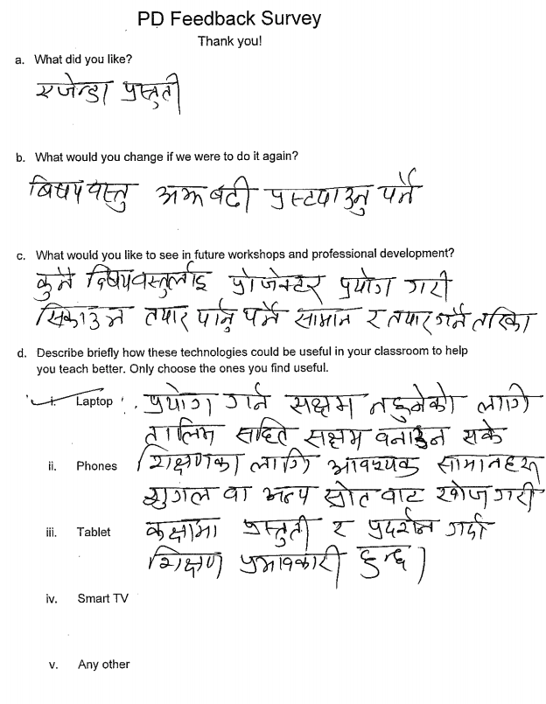
Figure 1. An example of a filled out survey (in Nepali) following a PD workshop.
[Translation: a. presentation of the agenda (objectives). b. greater clarity of content and context. c. process and tools to develop different contents for technology enhanced instruction. d. PD for those who are not proficient in many of these technology tools so they can use them to access materials from other sources to make classroom teaching more effective.]

Analysis

We analyzed data with an inductive approach (Miles, Huberman, & Saldaña, 2014). The researchers engaged in multiple, iterative conversations to discuss notes and memos throughout their time in Nepal and afterward as they coded data. These daily reflective conversations contributed to the study’s credibility (Shenton, 2004), especially due to the variances in experiences between the researchers in teacher PD, technology integration, and TPACK.
After our return to the United States, we each read through the data in its entirety, including the answers to the surveys. The authors took notes during their review of the data and artifacts and recorded memos regarding their initial thoughts (Saldaña, 2014). Data determined to be relevant were then organized into different categories of key concepts and to verify descriptive conclusions (Miles et al., 2014). The concepts were then organized into themes through consensus among the researchers. Researchers met again to engage in discussions of their conclusions and to ensure alignment between data and thematic findings, ultimately ensuring consistency in findings.

Findings

Our analysis of data illuminated three interconnected themes that provided insight into how and why technology integration can support more engaged pedagogy in the context of Nepal. The themes centered on relationship building for technology integration, prioritizing needs of the students and teachers, and balancing technology with pedagogy for learning.

Relationship building: A critical part of technology integration buy-in

To work toward a sustainable, long-term partnership, it was essential to build relationships with the administration and teachers at each school. Since we lived outside of Nepal, we prioritized taking time to understand the context and sociocultural dynamics of the school. We sat in classrooms to observe their current practices and as a step to build the relationship to support teacher buy-in for technology integration PD. These classroom sit-ins provided opportunities to get to know the teachers, their pedagogical approaches (PCK), and their students. The observations revealed several common pedagogical characteristics among teachers: teachers ask the questions and then all/most students recite the answer; when the teacher calls on a student they stand up to answer the question or do the task; students check their work and/or homework with the teacher throughout the class time; teachers and students heavily rely on the textbook for answers and notes; and students often turned to their neighbors if they were not understanding or not getting the correct answer. We also kept track of the nuances and strategies individuals used. Afterwards, we asked teachers more focused questions about the lesson (CK), the curriculum and their pedagogical choices (PCK), how they experienced it, and what or if they would do anything differently.

Early in our visits we began hearing how prior approaches to technology integration had felt for some teachers, and insight into their technological knowledge (TK). When we discussed the few OLPC laptops they had available, teachers were comfortable enough to share some of their reasons for not using them: “had [one] training on this awhile ago but forgot;” “kids struggled with the laptops;” “the screen is too small;” and “audio is too quiet.” Overall, these observations and conversations informed the design of our PD workshop. We determined it would be best to focus on pedagogical knowledge and methods for teachers, rather than solely on technology. These relationships ultimately led us to better understand the needs of the teachers and students, be flexible in our goals and design of workshops, and build the necessary foundational relationships for teachers to engage with us and be willing to try new things with their students (see Figure 2).

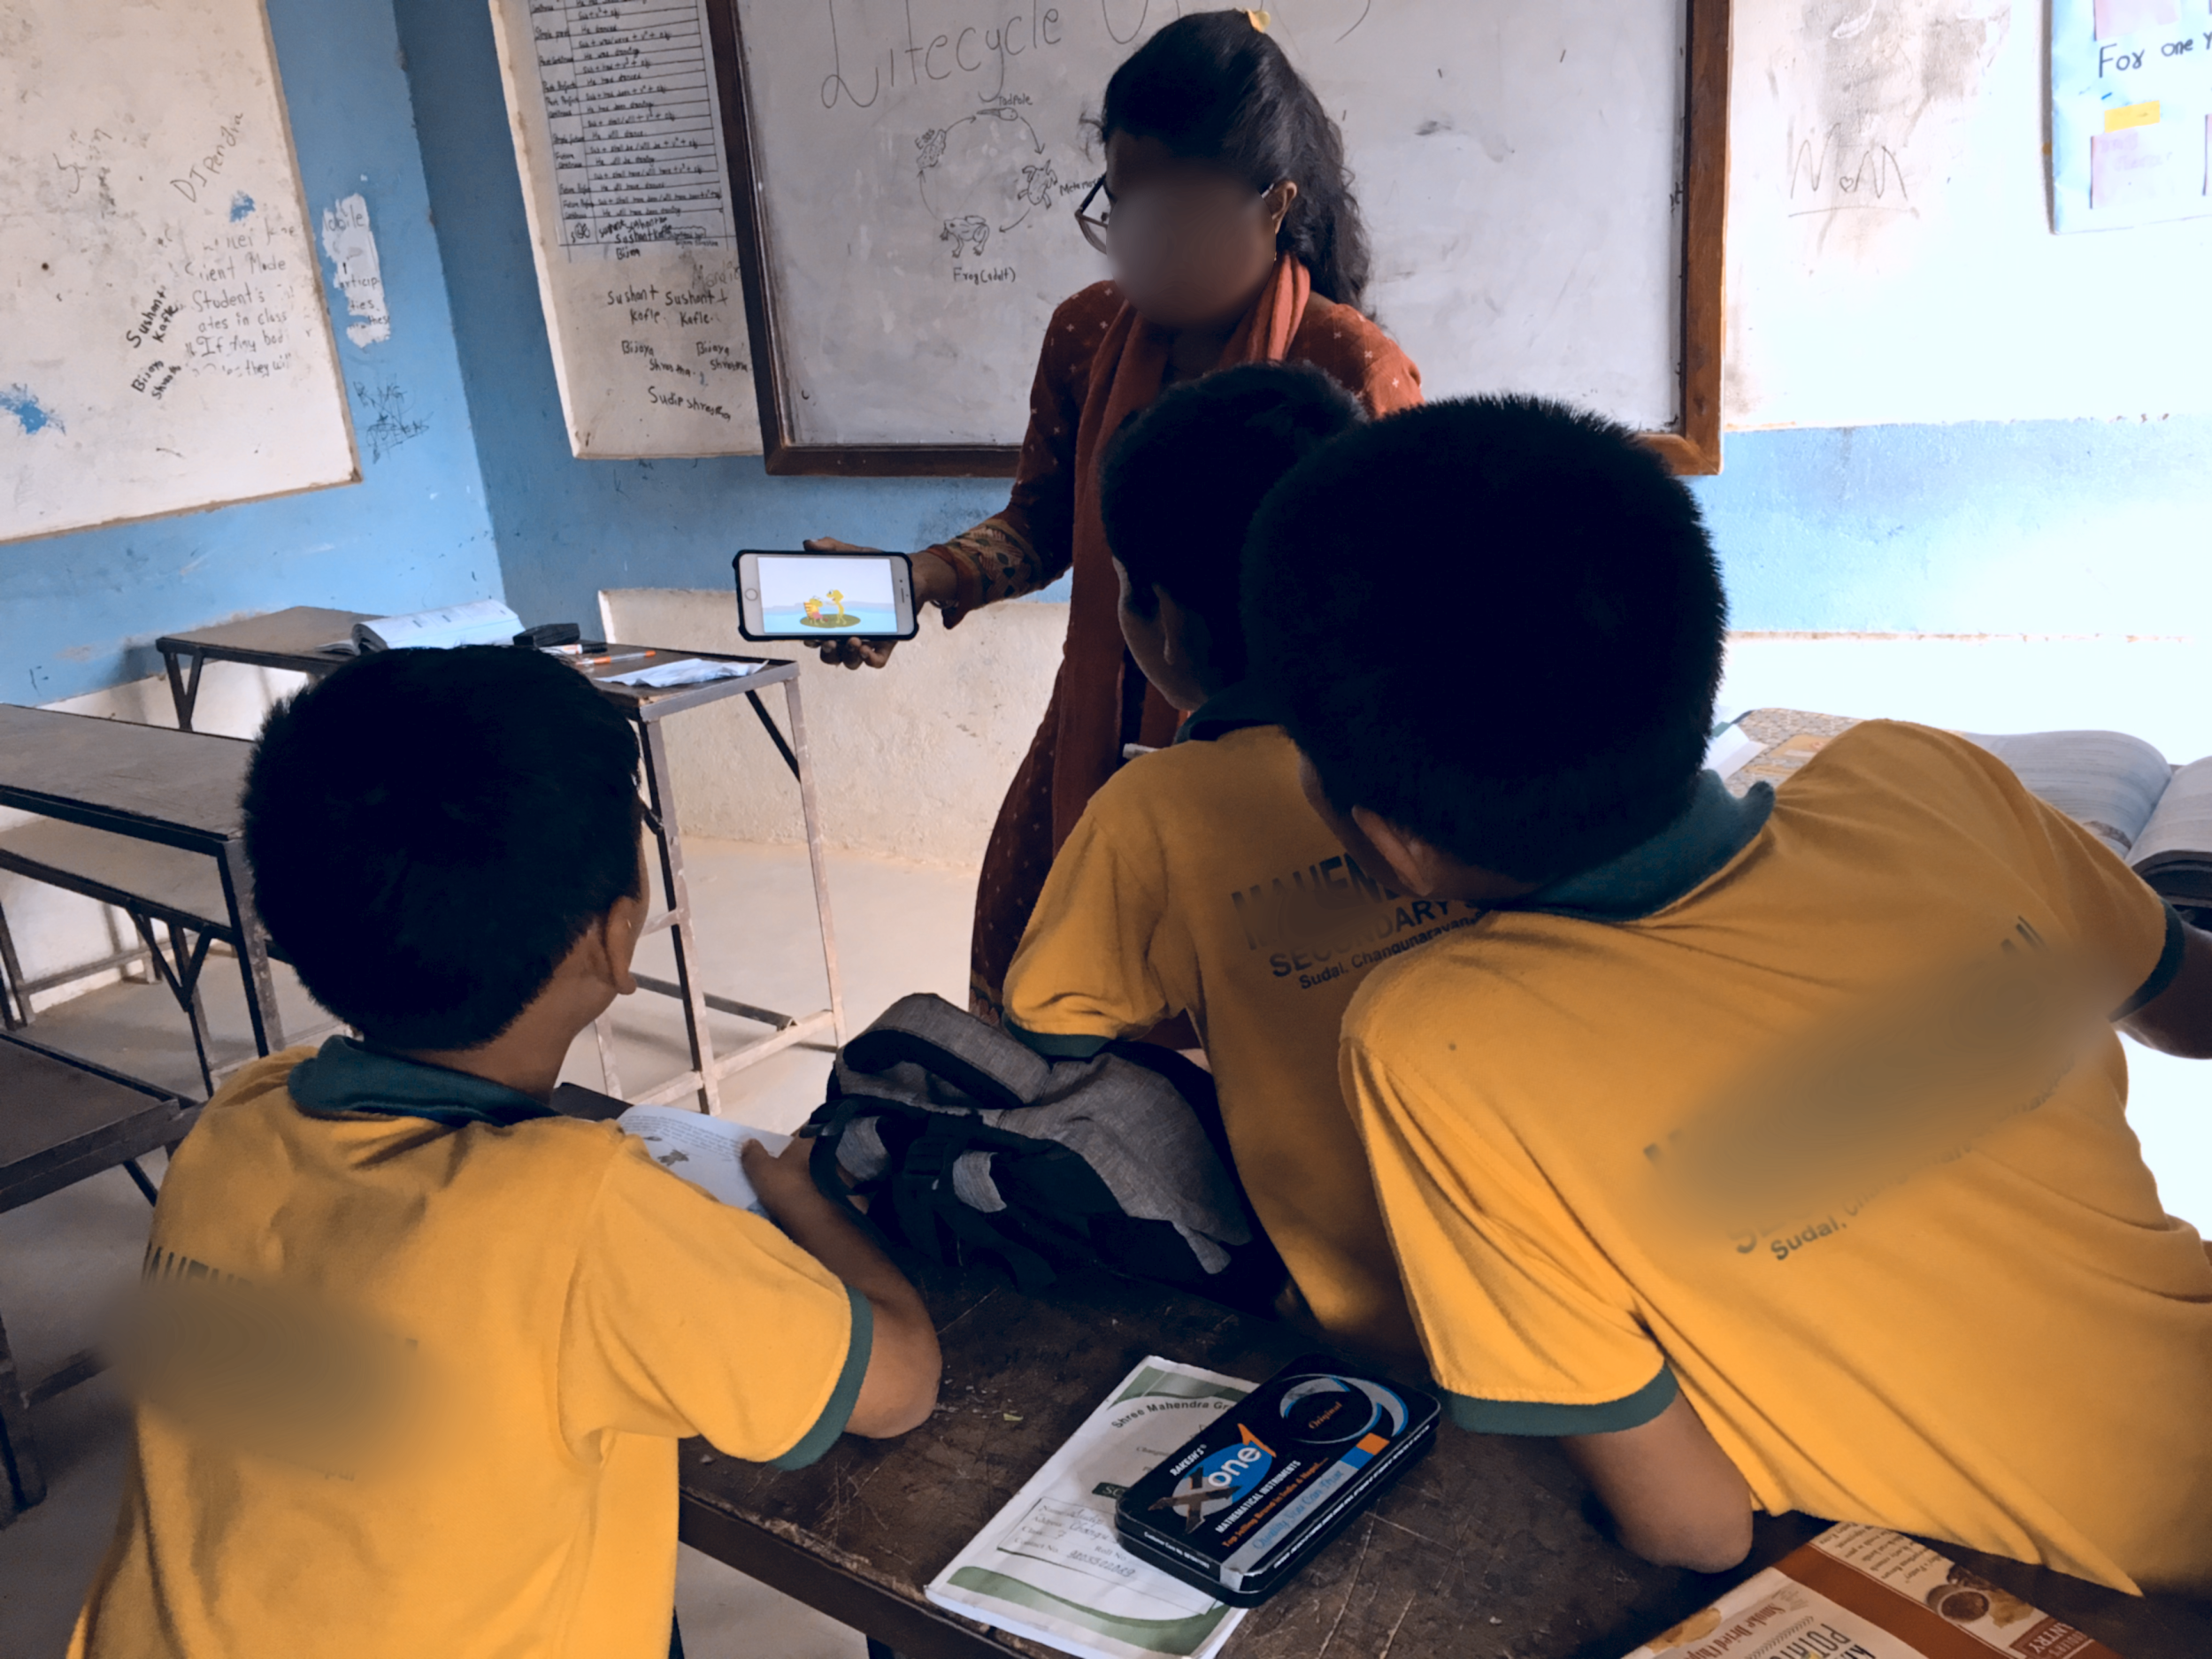
Figure 2. Following the PD, the Block B Social Studies teacher uses her phone to engage students.

Due to the trust and rapport between teachers and researchers, researchers were able to co-teach alongside them, and try new strategies. Some of the things we tried were: utilizing YouTube videos on a science topic in the curriculum (i.e., butterfly life), modeling an inquiry-based activity using collaborative groups to discuss science or cultural topics, and encouraging student-led discussion on the geography of a cultural holiday. These co-teaching experiences, in addition to the time spent observing and collaborating with teachers, provided an environment where the researchers were looked upon as assets rather than evaluators of their teaching. Furthermore, these hands-on interactions helped us ensure the design of our PD strategies were relevant (PCK) and aided us in identifying specific instances of how technology could be weaved into individual teacher’s content areas (TCK).

In the context of Nepali culture, status of an individual in the school, generally determined by one’s age or position, and community must be respected and adhered to, like an (assistant) principal. We worked with this cultural value to design and engage with teacher leaders in the school; we understood that without the support from the school administration and the more experienced tenured teachers, we would not gain trust nor build relationships with other teachers. Thus, we deliberately observed and co-taught science in the Block A assistant principal’s class. The assistant principal of the Block B building also invited us to observe his lesson, allowing us to strengthen our relationship as advocates and supporters of good pedagogy for all teachers. In both cases, we had some challenging conversations with assistant principals on the value of good pedagogy rather than just on content mastery for test success. We discussed the merits and drawbacks of test-centered pedagogy specifically in science, mathematics, and English. Ultimately, though, his answer was that “in our context test rules the day; unlike in the US [an erroneous belief among many Nepali populace that US schools do not place much importance on tests]. Therefore, we have to [our emphasis] teach for the test.” Given the context and educational system of Nepal, we understood their response, appreciated the candor, and decided to make sure we could connect the strategies we brought into the PD with this motivation that it will lead to increased student outcomes. The current caretaker principal and the previous principal in Block B were also very involved and active during the PD, which helped set the tone and mood for the other teachers and encouraged their engagement.

One of the science teachers, a respected leader in Block A, put us on the spot while teaching the life-cycle of a silkworm, a situation the researchers were unprepared for. Due to our understanding of the culture and role of this teacher, we respected his authority and showed our deference. This built trust and provided us with an opportunity to engage in a much more productive PD experience with him when the time came. Following the PD, the same science teacher shared with us that he could envision using the strategies we shared, “this PD helped me see how I can use… KWL [a teaching strategy] … inquiry… teaching [using] technology.” In another instance, an extra-curricular physical education teacher questioned the value of technology in her teaching. She believed that “technology was of little value to her teaching.” Due to our relationship with her, we assisted her in thinking about how “she could use technology to show [the] right ways to develop skills” and “physical activities.”

In these instances and interactions, we took teachers’ beliefs about technology, teaching, learning, and cultural norms to heart and designed our workshop to engage teachers in how good pedagogy - inquiry-based, student-centered, technology mediated, engaged, and hands-on - would both prepare students to experience better learning, and prepare them for the high-stakes test.

Prioritizing needs: Focusing on students, teachers, and schools

Our time in Nepal and at Sunrise School provided us with more insights into the needs of the school, teachers, and students. Originally we had planned our professional development workshops to be solely centered around technology integration, but after spending time at Sunrise school, we decided to take a different approach. The workshops were redesigned to focus more on theory and practical, relevant teaching strategies. Our observations and what we had learned about the school, teachers, and students guided our (re)design of the PD workshops. Based on our understanding of the Nepali culture, the current teachers’ pedagogies, and the necessity for students to be successful in their exams, our workshops focused on prior knowledge and collaboration, with specific strategies in mind for each.

Providing PD focused on specific pedagogical approaches to teaching (PCK), with strategies to integrate technology relevant to content (TPACK) being secondary, seemed a better approach because teachers suggested to us that those skills were valuable to them in this school context. Since students that attend the school came from diverse linguistic and cultural backgrounds with immense amounts of knowledge, (e.g., about nature, culture, farming practices, brick manufacturing, etc.), leveraging their prior knowledge as funds of knowledge would aid in adjusting pedagogy and uses of technology to make learning more culturally relevant to students. In this approach we engaged teachers in a simple tool called KWL-chart [What you Know (K)?; What you Want to know (W)?; and What you Learned (L)?] (see Figure 3). At the beginning of the workshop we asked teachers questions like, “What do you already know about integrating technology? About teaching?” “What value do you find in integrating technology in your teaching?” to find out what they knew/believed. This was followed by “What they wanted to know about technology integration and teaching in the workshop?” After the engagement in pedagogical strategies or technology integration activity, we would ask the teachers, “What did you learn about from that activity?” This modeling allowed teachers to practice and build skills to use KWL-chart in their class as a pedagogical tool and informed our understanding of their needs/wants.

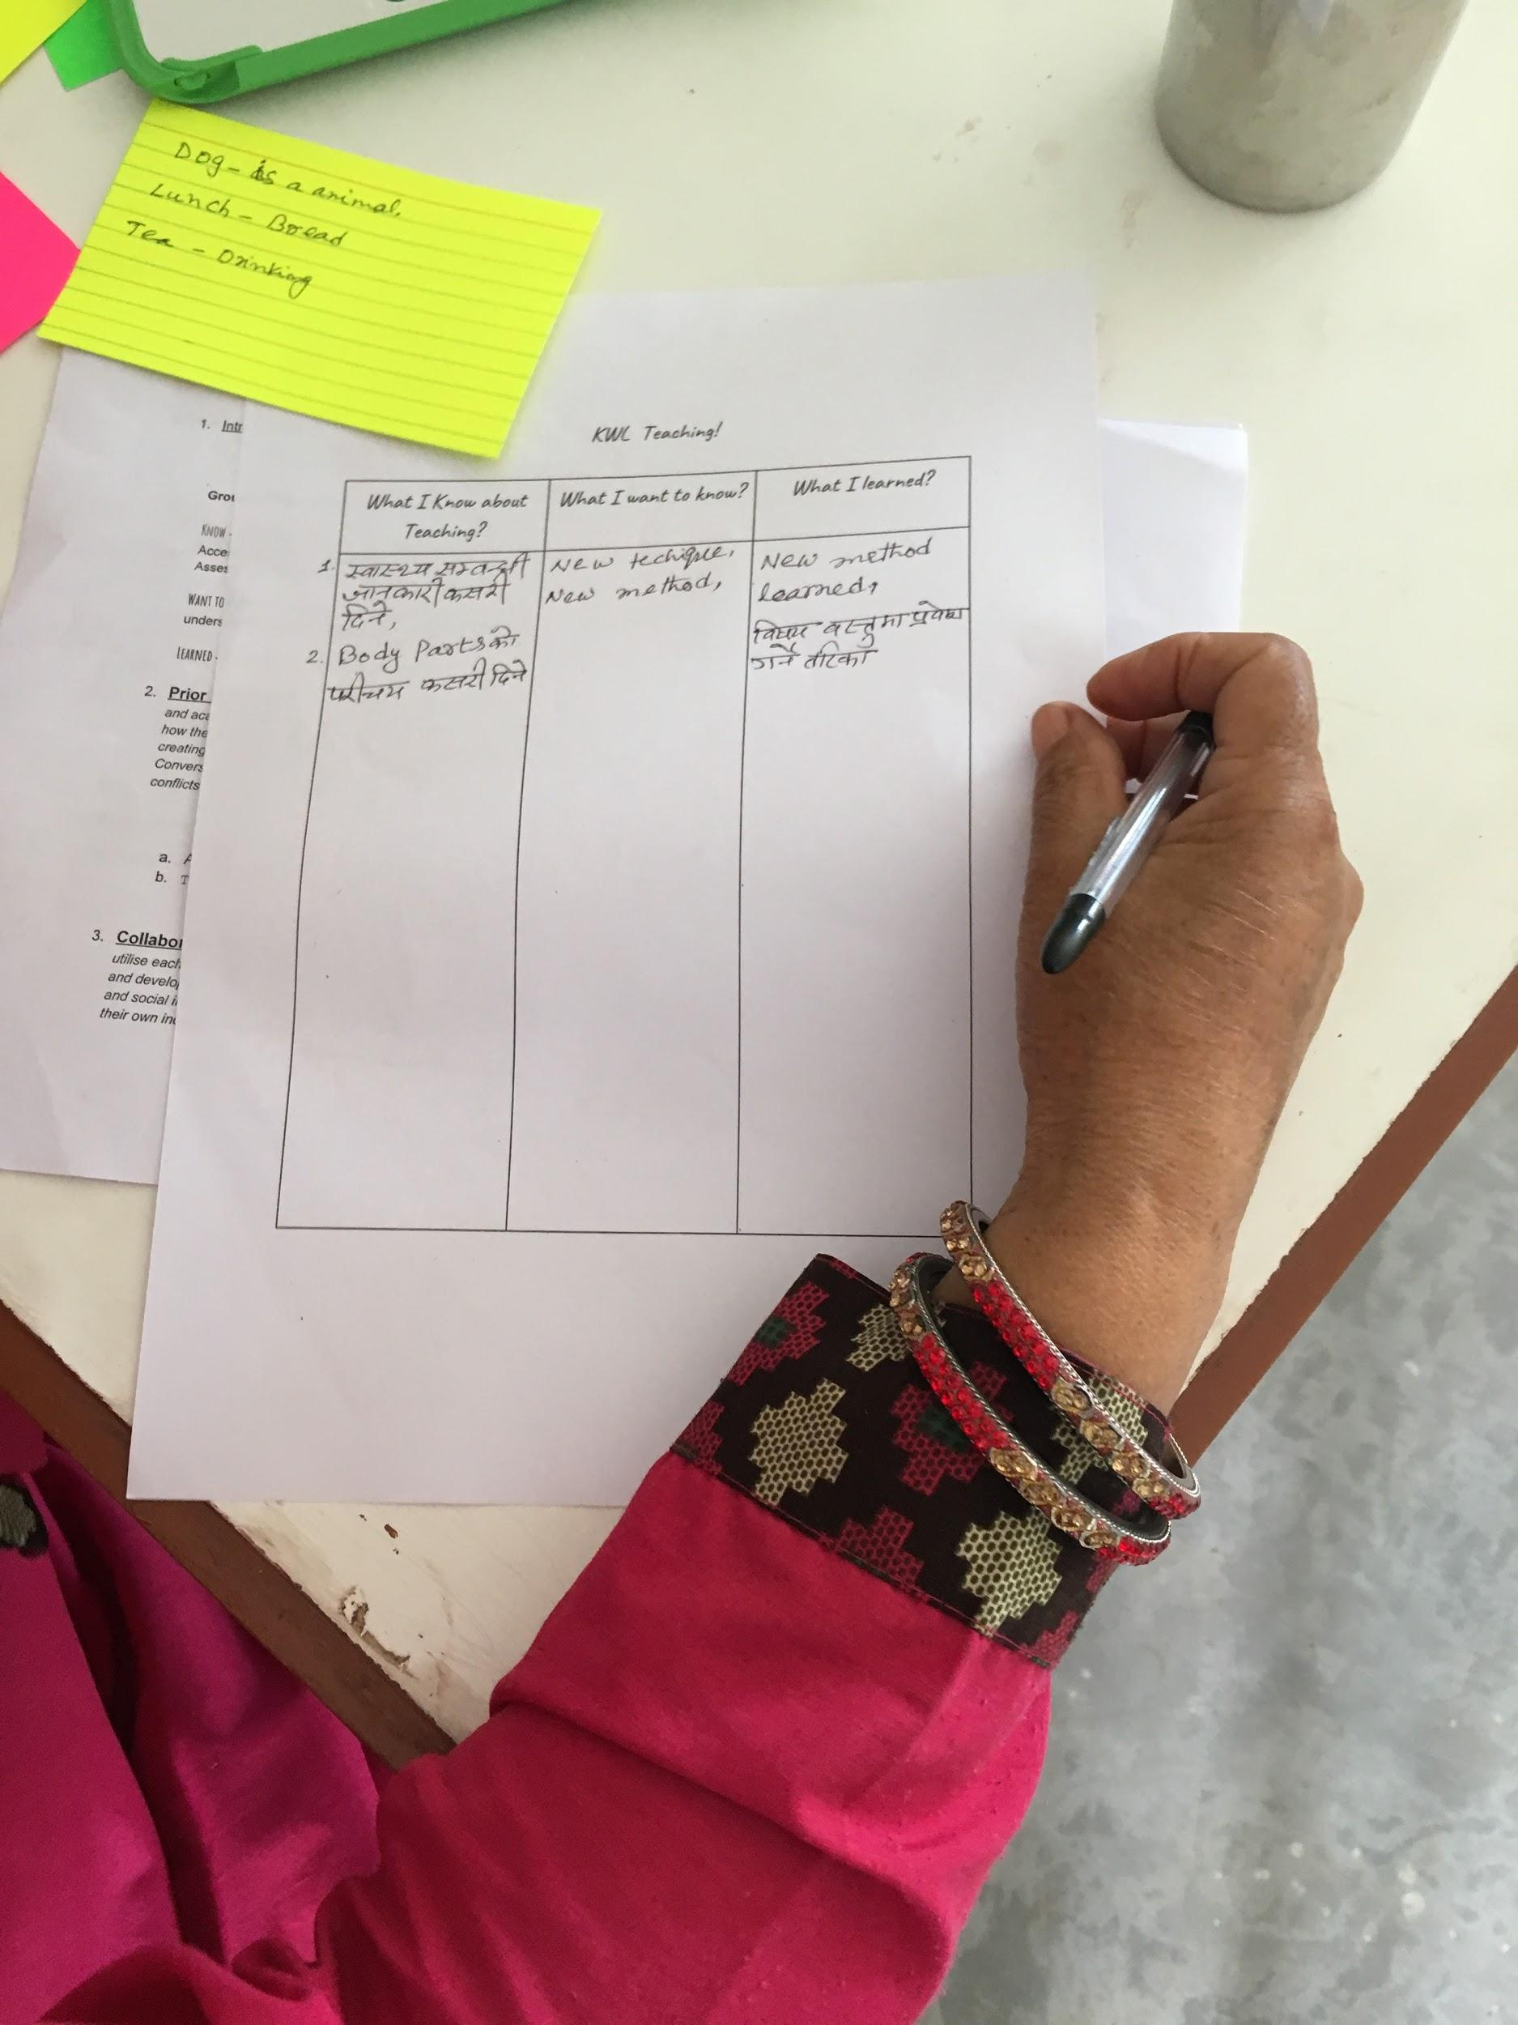
Figure 3. A Block B teacher works on filling out her KWL chart during the PD.

We designed our PD on the nature and value of collaboration having a transdisciplinary purpose. In our PD we asked teachers to work in random groups for two reasons: to show how they can leverage content from other areas to make learning fun for the students, and to also demonstrate how they can use technology to facilitate collaborative efforts (see Figure 4). To ensure our PD was not a one-time event, we used co-teaching as an extension to meet the needs of the school, teachers, and students. We encouraged/assisted teachers in using a strategy they had practiced in the workshop, like role cards for groups, and when co-taught, we would also model or offer other ideas of how to integrate technology specific to the teacher’s content area and to meet the learning needs of their students.

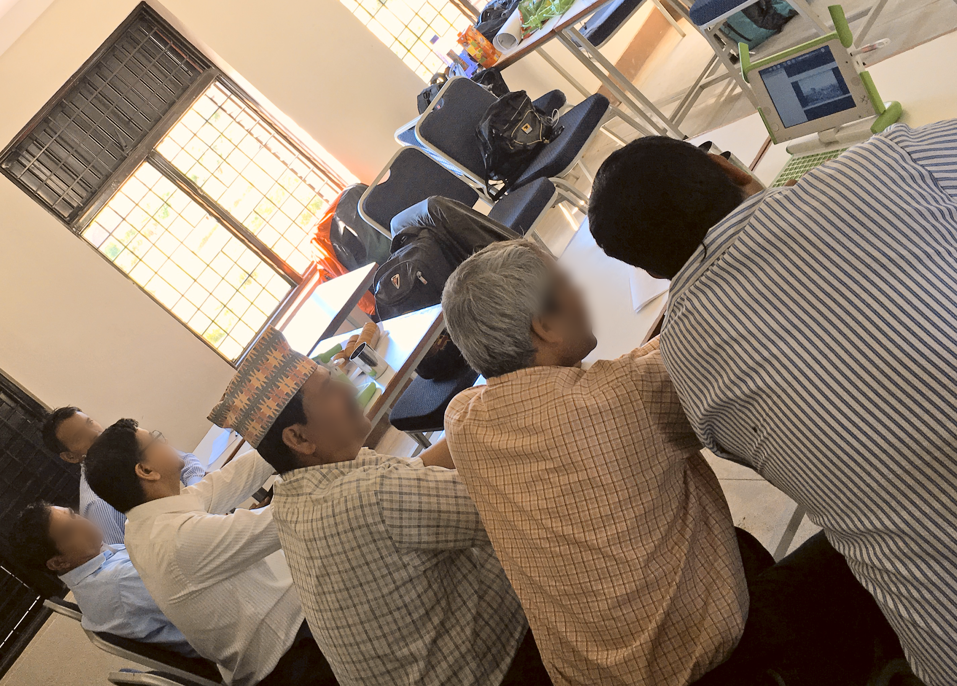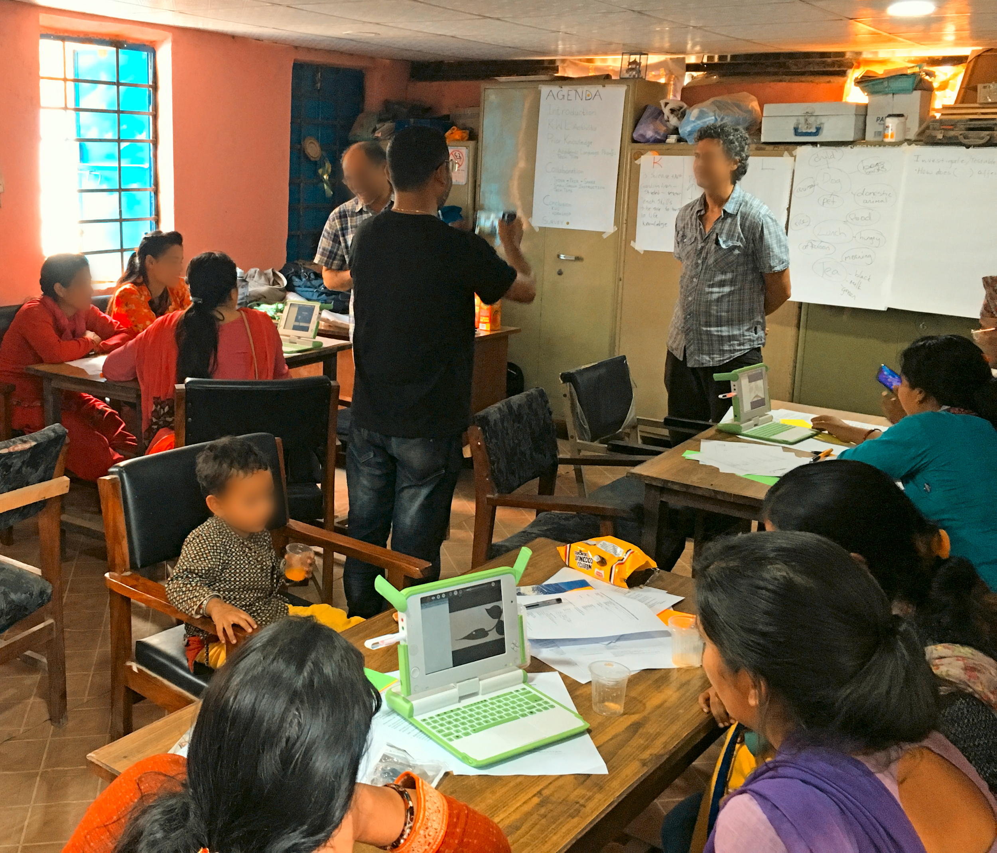
Figure 4. Teachers from Block A [pictured left] and B [pictured right] work in small groups to explore the laptops and discuss application of strategies to their content area(s).

For example, students in social studies were studying the history and culture of Nepal and the Kathmandu Valley, and one of the topics was cultural heritage. The students were learning about Rato Machindranath, the deity of timely and abundant rain, but did not seem to be making personal connections to the material. One of the researchers, who explores technology in social studies contexts, observed this lesson being taught. Working with the teacher, he suggested that they enhance the lesson using available technology in the school. They incorporated the technology while co-teaching the lesson, and also referenced it during a PD workshop to share with all of the teachers. While technology helped enhance the lesson, the focus remained on assisting teachers and students in learning the content and ideas about culture and history. During the PD, a Nepali language and a mathematics teacher found this example inspirational and commented: “this would be great when I teach Nepali language and use different cultural backgrounds of our students''; “this could be useful in my math class...I can see how I can show geometry concepts and its use in different Nepali cultural [temples and stupas - cultural structures].” Similarly, the English teachers found the use of technology to be beneficial in order “to practice sentence structures and writing in a ‘quick’ way… you can erase and repeat...practicing [skills] of sentence structures.”

Ultimately, the purpose of the PD was to meet the needs of those within Sunrise school, which meant providing tools to encourage and support teacher experiences with practical pedagogical strategies (PCK) and ideas for technology integration in this school (TPACK). The technology integration piece was always about modeling how and why even limited technology use could improve their own pedagogical skills, but more importantly, how it benefited students’ experiences in learning.
Pedagogy and limited (mobile) technology: A balancing act

While both students and teachers were very interested in having technology in their classrooms, it was critical that our focus emphasize pedagogy and unplugged strategies to be most useful and relevant. As researchers and practitioners, we wanted to ensure that any PD and/or suggestions around technology took into consideration access to technology tools and teachers’ TPACK. These domains are interconnected and may feel fluid in practice. Therefore, during our workshops and in the classroom, we explicitly centered the use of the tool around pedagogy and why it might be beneficial, and ensured it was a technology the teacher(s)/school had access to. We quickly learned of the barriers to technology integration in Nepal and specifically at Sunrise school, which included lack of internet, training, and electricity, and high cost. The technology that was most readily available were mobile technologies like smartphones, and a limited supply of laptops.

Despite the physical limitations and barriers to technology use in the classroom, the students and teachers still demonstrated interest in using technology. During informal conversations teachers would say, “Yes. Technology would give us a chance to show ‘abstract’ concepts” and “access to the internet would help but school has restricted it for other purposes … not for teaching.” One teacher felt “Youtube and other resources might help teach science showing simulations of science content and concepts.” Their attitude focused on the use of technology as a way to enhance effective teaching and learning, but they also had a lot of questions (e.g., best ways to use technology, how to prevent distractions, time to find resources, etc.).

Whenever we could introduce technology, usually in the form of a video or local pictures we took, students were excited to see the multimedia (see Figure 5). The researchers used their personal devices during co-teaching and when invited while observing a class. Since our devices were limited to small phones or a laptop, we would either have students crowd around us, or show the same video in different groups between the three of us (particularly for large classes). Our actions modeled how technology, even when limited, could be an asset to student-centered teaching and inquiry-based learning. In a fourth-grade science class, one of the researchers and the class teacher co-planned a lesson on the butterfly life cycle. To show the life cycle, the researcher selected an age-appropriate, short video for the class. During co-teaching the video was incorporated into the lesson and enhanced students' science experience as they excitedly gathered around to watch the video. We observed them say: “Wow, that is what the picture in the book is showing”; “Did you see how the butterfly come[s] out of [the cocoon]?”; “I didn’t know what [the] chrysalis (pupa) stage was about…. did you know [pointing to the friend]?”

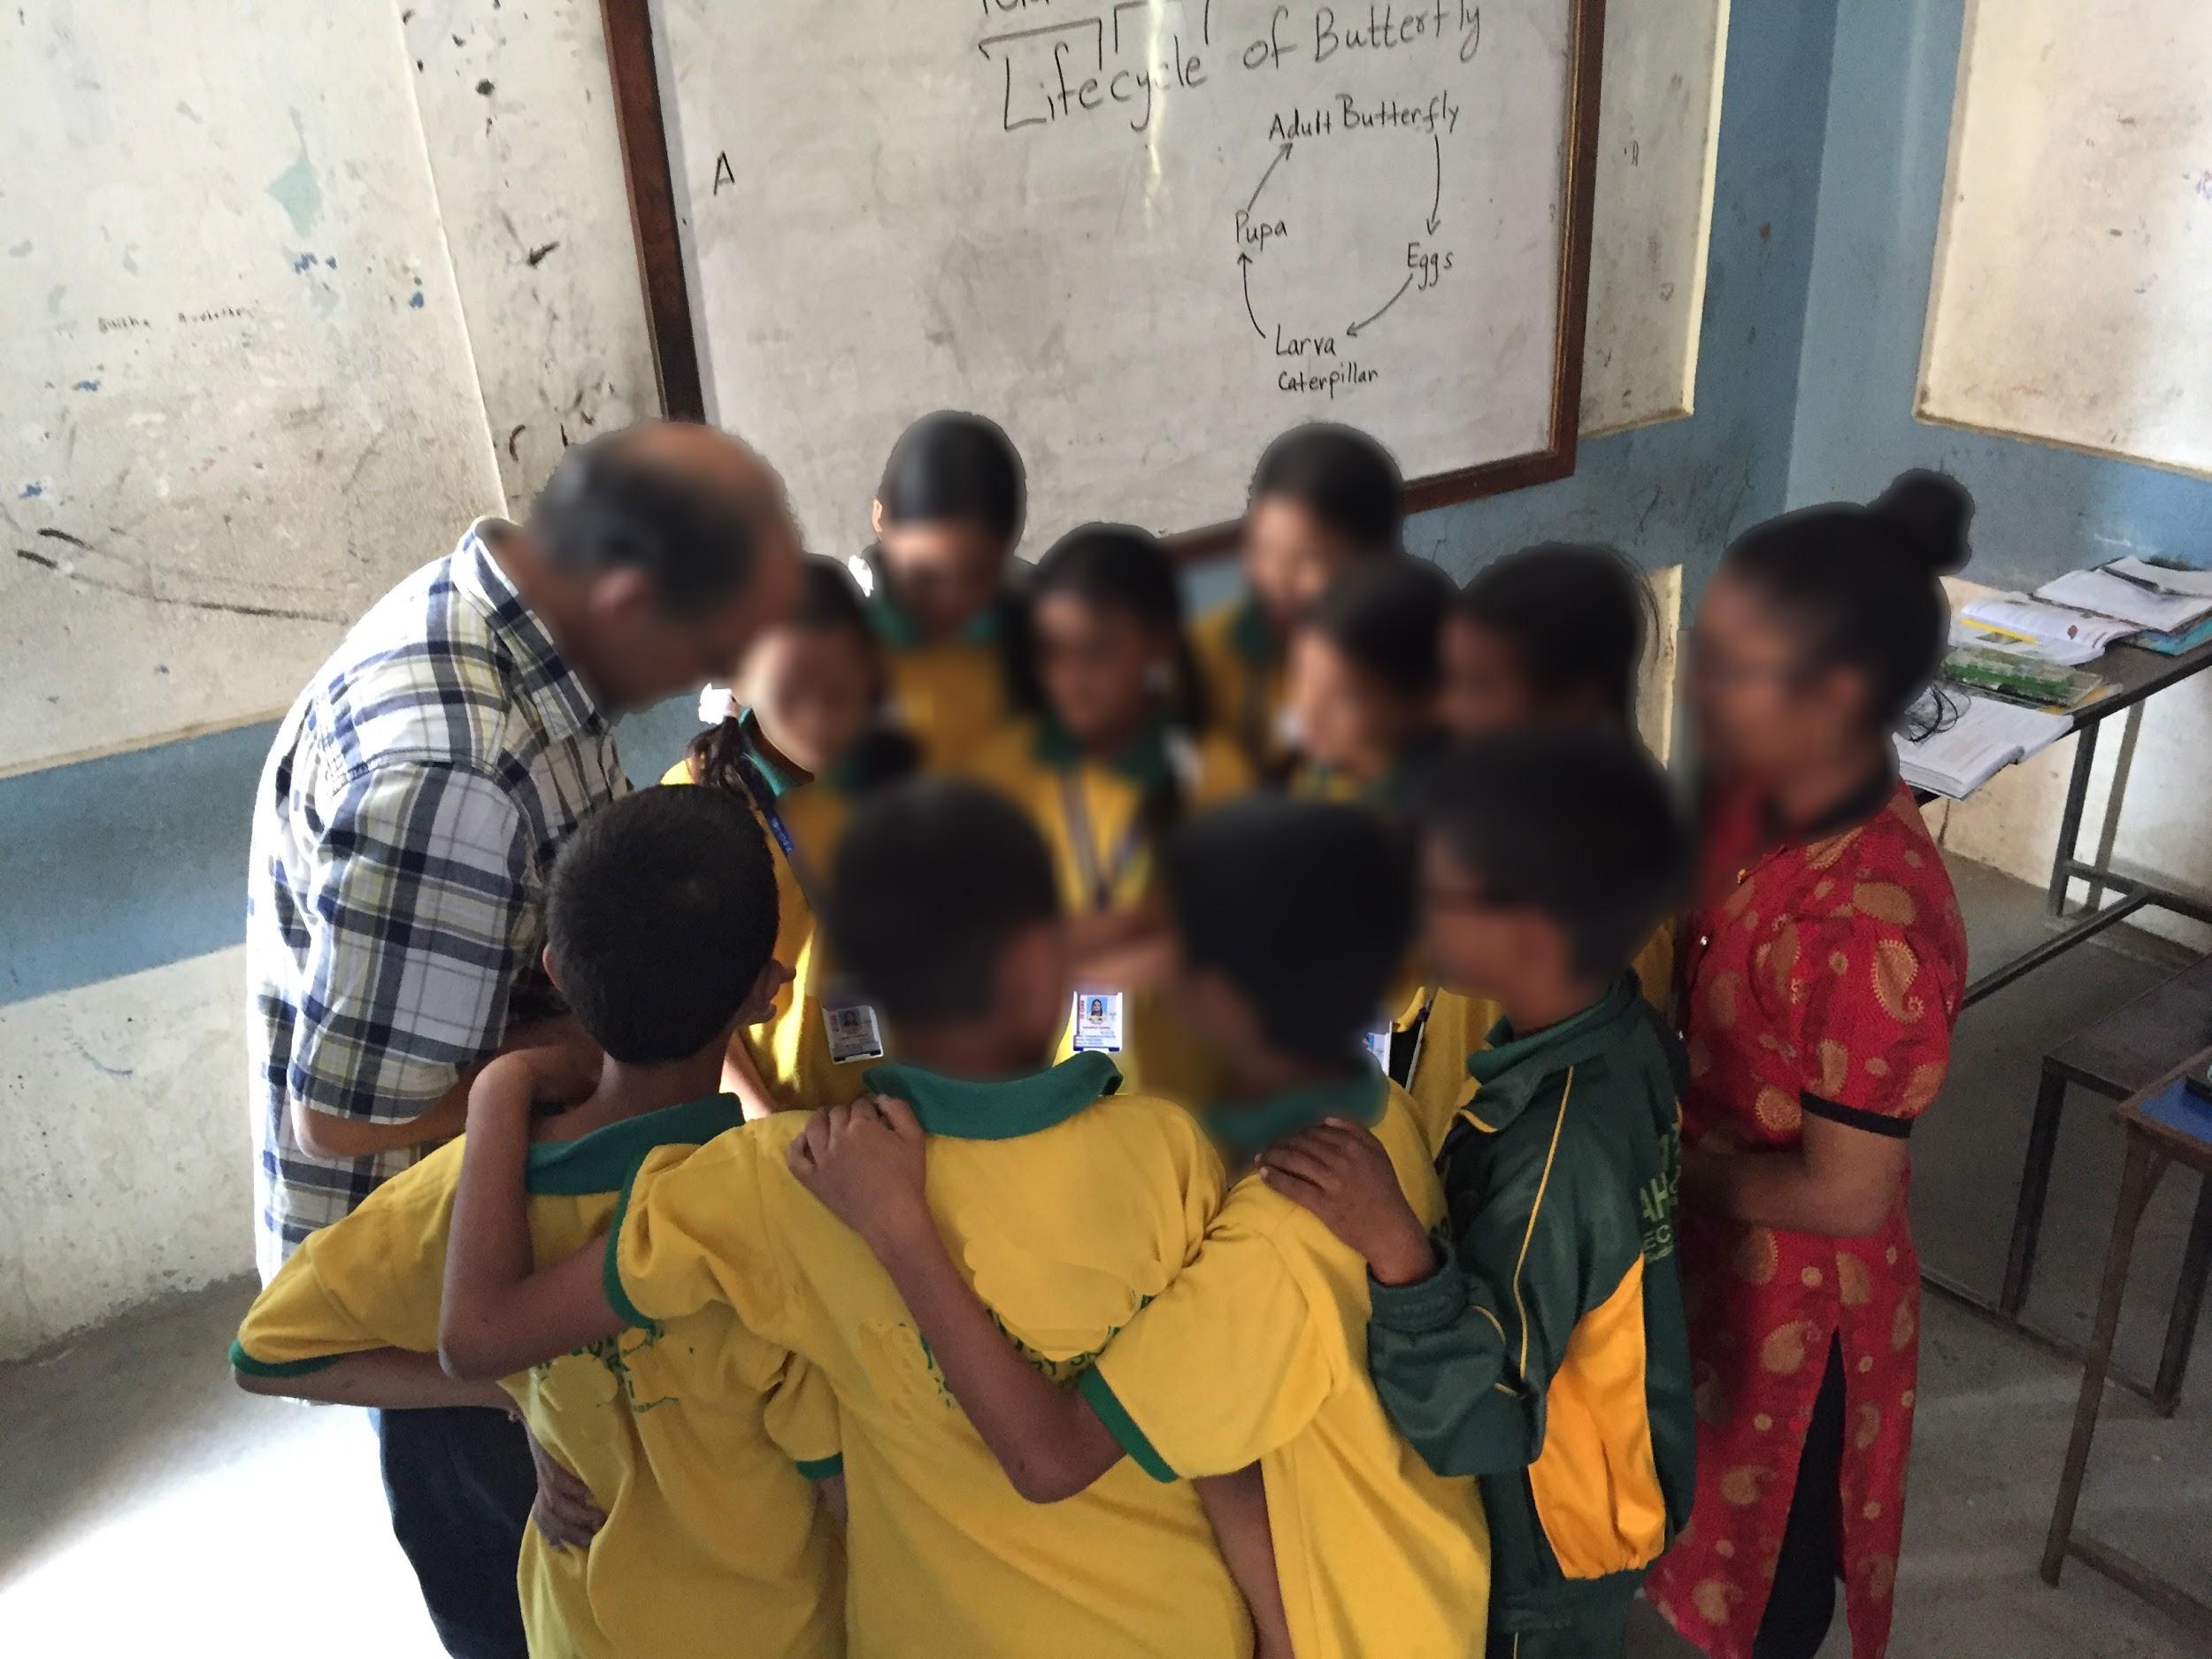
Figure 5. Students and their teacher express interest in a Youtube video depicting a butterfly’s life cycle, shown on a researcher’s mobile device.

Another researcher used their mobile device to provide local context through the form of photos they had recently taken and to encourage personal connections and deeper engagement from students who were tasked with writing a cohesive, short paragraph about a local World Heritage Site (Swayambhu) in their English class. In this class, the technology use modeled how to engage students in ‘personally connected’ writing and encouraged collaboration as they shared their stories, experiences, and ideas with one another. In another instance, after the PD, the high school mathematics teacher approached the researchers with his own idea of recording his lessons to share with students who were absent, something that was common in this area. One of the researchers used a mobile device and recorded the lesson (see Figure 6), and while reviewing the video, the teacher and researcher discovered another potential use of the recorded lessons - reflective practice. The teacher commented on things he noticed about his own teaching and thought he could also use it to showcase effectiveness in teaching for promotion. He also shared this experience with his colleagues at the school, they discussed pedagogy to engage students and the teacher's practice of making mathematics concepts, in this case geometry, relevant to students.

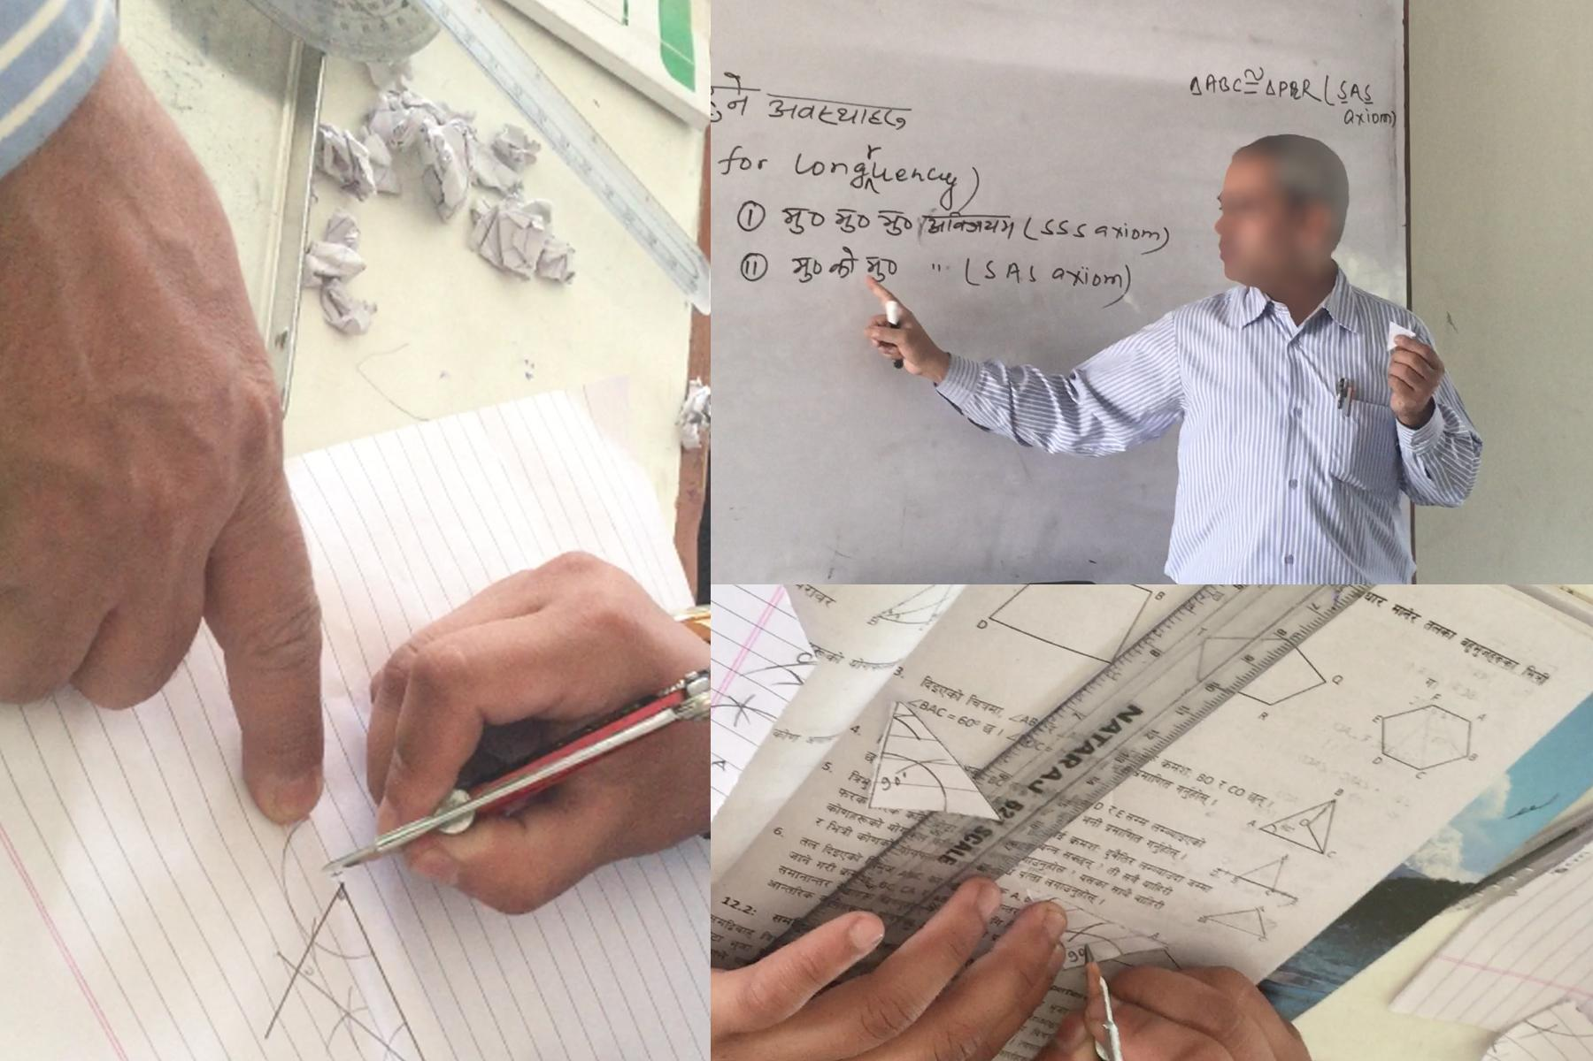
Figure 6. The math teacher from Block A [pictured above] teaches a geometry lesson and assists students.

Our time with teachers and the PD is promising as it showcased meaningful and intentional integration of mobile devices for various content areas, and highlighted the teachers’ positive, eager reception to these ideas and their excitement to explore ways to integrate it. However, the time spent at the Sunrise school with the teachers showed us that more learning experiences and support is needed to: increase their technological knowledge (TK), overcome or mediate some of the barriers to technology integration, like the personal financial cost to teachers because “they are not reimbursed” as the principal noted to us, and/or address the previously held beliefs that teachers may abuse using mobile phones in the classroom.

Discussion: Limitations and Implications

The findings indicate that there is great value in modeling technology integration and supporting teachers in resource-deprived schools, specifically in the Global South. Despite some obstacles, technology can assist in making interdisciplinary connections that enhance students’ learning experiences more feasible. Since the focus of teaching and learning seemed to be for passing the high-stakes tests at Sunrise School, our study pointed towards a possibility that there are spaces where teachers could enhance student learning through cultural inclusivity and technology integration based on students’ cultural background. Finally, a collaborative relationship seems to be a key aspect of successful buy-in from teachers. In this section, we discuss limitations, implications for research and practices, and future directions.

Limitations

It is important to note that this study is not representative of all Nepali teachers, but rather explores how certain PD strategies and intentional, relevant technology integration supported more engaged learning and teaching. A perceived limitation to this study may be related to case study methodology and its interpretive nature. Case studies are qualitative in nature and assume that “reality is holistic, multidimensional, and ever-changing,” and the researchers’ interpretations of the phenomenon/reality were accessed directly through our observations and interviews (Merriam, 1998, pp. 202-203). There are a multitude of possibilities to consider that could have contributed to the experiences shared within this case study, including the size and timing of the partnership, the presence of the researchers, access to technological resources, the teachers’ diverse experiences and backgrounds, and the intersectionality of their identities.

Another key aspect of our study is the context of the school community. During the PD many internal migrant workers had left the area, which impacted the school’s enrollment and our own observations of what other elements the PD should include to improve teacher pedagogy and potential technology integration for migrant children. We consider our study’s findings to be relevant for the school but also acknowledge the missing population of students who could have led to different emergent findings. Yet we believe this study adds to the continuing conversations in technology integration in classroom teaching research. This study points us to the possibilities and contextual aspects of TPACK in teachers’ effectiveness integrating mobile and limited technologies in their everyday pedagogical practices.

Implications for research and practice

We believe our study makes important contributions in the area of PD that enhances technology integration in content areas and insight into building long-term partnership between university and local school in the context of Global South.

Technology & PD is not one size fits all

One of the great challenges in educational improvement studies is that there is not a ‘one size fits all’ model, nor do they provide a ‘silver bullet’ to remedy all pedagogical and learning challenges (National Board Resource Center [NBR], 2012; National Research Council [NRC], 2011). Studies in all content areas have shown that the contexts of community, culture, students, curriculum, policy, and many other factors, including technology resources, influence the success of a PD for teachers (Yurtseven Avci et al., 2019; NBR, 2012; Upadhyay, in press; Upadhyay et al., 2021). Thus, this study also illuminates the disconnect that is often present in Western researchers’ assumptions of technologies in school and in non-profit initiatives from outside communities they are trying to help (i.e., “one laptop per child” (Rana et al., 2018), which Sunrise school was a beneficiary of). These well-intentioned efforts do not fit the on-the-ground realities of the school. This study shows that the community’s needs and voices should be centered, so conversations with the teachers and students are key to understanding the context and to ensuring a PD design that benefits the stakeholders (Uzorka et al., 2021), rather than the researchers’ pre-determined goals. This study supports prior research on PD of technology-enhanced teaching and learning where goals that are set by the teachers generate more useful and lasting influence on the development of their TPACK and inquiry skills, rather than predetermined, researcher-set goals (Unger & Tracey, 2013; Yurtseven Avci et al., 2019).

Importance of cultural understanding & context

This study illustrates the importance of cultural contexts in teaching and learning. The teachers, students, and the school at large had different sociocultural norms on teaching, learning, testing, and technology integration, as did the researchers. The researchers in this study were outsiders for the teachers and students, despite the second author being raised and educated in Nepal. Sociocultural and language barriers were mostly mediated and supported by the second author, but some teachers and host family members were equally influential in supporting the team in this area. Studies have shown that understanding, respecting, and valuing local culture is the foundation for the success of new knowledge and skills (Lalley et al., 2018; Upadhyay et al., 2021).

Studies have shown that to bring positive and supportive changes in teachers’ dispositions about technology integration in teaching, valuing and imbedding their beliefs and culture in the PD and activities are central to success (Ertmer et al., 2012). Our study agrees with the assertions as a focus on cultural understanding and context of the school supported a positive outcome from the PD on teachers’ technology integration. For example, one of the researchers was invited to co-plan and co-teach a lesson on mathematics, with the inclusion of technology, because the teacher saw value in it but, “more importantly, I [math teacher] saw your respect for us [teachers] to help us learn what we [teachers] don’t know.” We see how essential building the rapport, trust, and respect was for this teacher. In addition, we wonder if the high school mathematics teacher would have still asked a non-content matter expert (like this researcher) to co-plan and co-teach content integrating technology if the research team had not valued the Neplai cultural norm of respect and the context of the school.

Value of mobile technologies

Mobile technology has transformed many Global South communities by providing them access to resources, economic entrepreneurship, and building gender equity (Crentsil, 2019; Larson & Stark, 2019). While the United Nations’ Sustainable Development Goals (SDGs) do not specifically target ICT as a goal, technology is mentioned within many of the goals, including Goal 4: to ensure inclusive and quality education for all and promote lifelong learning (Wagner, 2018, p. 52). It does not come as a surprise then that many countries continue to prioritize integrating ICT into education, depending on their context. In Nepal and this school’s context, teachers are very skilled and comfortable accessing and sharing through mobile technology, and personal cell phones were the most available technological support. In our own PD we modeled utilizing our own mobile devices to show how we could use technology to enhance some of the content, expand access to resources, and support learner-centered pedagogy. Our study showed that teachers benefitted from our modeling of mobile technology integration in science, social students, English and math classes. Mobile technology allowed teachers to use it for instruction and to reflect on their teaching practices. Therefore, we believe policy makers in GS could provide incentives (eg. yearly fixed financial contribution) and appropriate PDs to encourage teachers to use personal mobile devices in their classrooms more regularly to enhance pedagogy and student learning.

Emphasis on relationships

Sustainable change is possible only through strong and mutually respectful relationships (Schulz & Hall, 2004; Upadhyay et al. 2021). When university-school partnerships or collaboration are built on the grounds of respecting and valuing what each side brings, the relationship engenders positive outcomes (Darling-Hammond, 2006; Upadhyay et al., 2021; in press; Zeichner, 2010). Some scholars have also found that relationships built on supportive environments for the exchange of new and challenging ideas both strengthen the professional partnership and generate positive and culturally relevant outcomes (Hargreaves & Fullan, 2012; Herbert et al., 2018).

The successes we experienced in our PD and co-teaching experiences are supported by other studies that have indicated partnerships built with long term goals (Kruger et al., 2009) and limited hierarchical fences (Zeichner, 2010) produce better working relationships. Similarly, prior research on university-school partnerships support our findings of better working relationships with the teachers and school when the relationship is built on valuing teacher voices and incorporating them in our PD (Berger & Johnston, 2015; Price & Vali, 2005; Ure et al., 2009). Studies on co-generative teaching and planning show similarly successful results when the stakeholders are part of thinking, planning, and implementation (Dornar & Kumar, 2016; Upadhyay et al., 2011).

A commitment to sustainable and long-term partnership is a hallmark of success and trust among the stakeholders. We caution the findings of international development works in countries like Nepal and the Global South, in general, because they tend to be fleeting and temporary, making all the gains and trust between the partners disappear very quickly. Therefore, we want to avoid this by ensuring we are building an ongoing, strong partnership among the three partners-- the school, a US-based non-profit philanthropic foundation, and the western university. We and the school teachers see this partnership as a three legged stable stool with many more gains for the students.

Future directions

We hope this study becomes more longitudinal in nature as the partnership between the university, Sunrise school, and the philanthropic foundation continues long into the future. There are still many lessons to be learned such as helpful practices to encourage the sustainability and growth of the professional development, shifts in teachers’ confidence in technology integration, the long-term and/or academic impact of pedagogical changes on teachers and students, and strategies to best support and engage children of internal migrant workers. In the future, we encourage further research for the improvement of inclusive pedagogies and participation for teaching and learning in Nepal, and more broadly, in many multicultural communities across the world. In order for us to further our learning and help teachers and schools like Sunrise in Nepal, we need to research what (how/why) works, what (how/why) does not work, and what (how/why) needs improvement. Answering these questions will aid in better design of PDs, partnerships, resources, and ultimately provide the necessary support to teachers, parents, and students in teaching and learning.

Conclusion

This study points to the value of contextually relevant technology integration. The findings suggest that teachers from a Nepali school benefitted from PD that focused on developing technology-enhanced pedagogy. The study identifies and supports an important component to a successful university-school collaborative PD: building relationships through cogenerated PD that values local school teachers’ goals and aims to enhance student learning. For western universities to influence student-centered and inquiry-based technology integration, local sociocultural contexts and needs must be a central part of the collaborative partnership. We believe the findings from this study could serve as a potential model for a mutually respectful, collaborative, and sustainable technology integration PD design for many schools in the Global South. Finally, we recognize that unforeseen events like COVID-19 could disrupt continuity in this kind of collaborative partnership. However, once the concerns of COVID-19 are alleviated, this partnership will resume supporting teachers in Nepal with technology-enhanced professional development and other collaborative activities supporting all students’ educational success.

Acknowledgements or Notes

We thank JRM Foundation for Humanity and International Initiatives and Relations, College of Education and Human Development (CEHD), University of **** for their support for this work. The ideas and opinions expressed in this paper are those of the authors not the institutions.

References

Anderson, J. R., Greeno, J. G., Reder, L. M., & Simon, H. A. (2000). Perspectives on learning, thinking, and activity. Educational Researcher, 29(4), 11–13. https://doi.org/10.3102/0013189X029004011
Barksdale, S. (2018). Assessment with technology integrated menus: Creating a bridge between traditional and student-centered learning. In Proceedings of EdMedia: World Conference on Educational Media and Technology, 250-255. https://www.learntechlib.org/primary/p/184205/
Berger, J. G., & Johnston, K. (2015). Simple habits for complex times: Powerful practices for leaders. Stanford University Press. https://doi.org/10.1002/ltl.20201
Brush, T., & Saye, J. (2000). Implementation and evaluation of a student-centered learning unit: A case study. Educational Technology Research and Development, 48(3), 79–100.https://doi.org/10.1007/BF02319859
Central Bureau of Statistics. (2011). National population and housing census 2011 (national report). Retrieved on December 2019 from https://unstats.un.org/unsd/demographic-social/census/documents/Nepal/Nepal Census-2011-Vol1.pdf
Chien, Y., Chang, C., Yeh, T., & Chang, K. (2012). Engaging pre-service science teachers to act as active designers of technology integration: A MAGDAIRE framework. Teaching and Teacher Education: An International Journal of Research and Studies, 28(4), 578-588. https://doi.org/10.1016/j.tate.2011.12.005
Ching, C., & Hursh, A. (2014). Peer modeling and innovation adoption among teachers in online professional development. Computers & Education, 73, 72-82. https://doi.org/10.1016/j.compedu.2013.12.011
Collins, L. J., & Liang, X.. (2015). Examining high quality online teacher professional development: Teachers' voices. International Journal of Teacher Leadership, 6(1), 18-34. https://eric.ed.gov/?id=EJ1137401
Courduff, J., Szapkiw, A., & Wendt, J. (2016). Grounded in what works: Exemplary practice in special education teachers’ technology integration. Journal of Special Education Technology, 31(1), 26-38. https://doi.org/10.1177/0162643416633333
Crentsil, P. (2019). Reinforcing inequities? Mobile telephony and HIV/AIDS in Ghana. In C.W. Larsson & L. Stark (Eds.) Gendered power and mobile technology (pp. 125-147). Routledge.
Cuhadar, C. (2018). Investigation of pre-service teachers' levels of readiness to technology integration in education. Contemporary Educational Technology, 9(1), 61-75. https://eric.ed.gov/?id=EJ1166420
Darling-Hammond, L. (2006). Constructing 21st-century teacher education. Journal of Teacher Education, 57(3), 300–314. https://doi.org/10.1177/0022487105285962
Darling-Hammond, L., Hyler, M. E., & Gardner, M. (2017). Effective teacher professional development. Learning Policy Institute. https://learningpolicyinstitute.org/product/effective-teacher-professional-development-report
Dorner, H., & Kumar, S. (2016). Online collaborative mentoring for technology integration in pre-service teacher education. TechTrends: Linking Research and Practice to Improve Learning, 60(1), 48-55. https://doi.org/10.1007/s11528-015-0016-1
Encyclopedia Britannica (nd). Retrieved from htpts://www.britannica.com/place/Nepal/Administration-and-social-conditions
Ertmer, P., Ottenbreit-Leftwich, A., Sadik, O., Sendurur, E., & Sendurur, P. (2012). Teacher beliefs and technology integration practices: A critical relationship. Computers & Education, 59(2), 423-435. https://doi.org/10.1016/j.compedu.2012.02.001
Hanover Research (2014, June). Professional development for technology integration. Hanover Research. Retrieved from: https://ts.madison.k12.wi.us/files/techsvc/Professional%20Development%20for%20Technology%20Integration.pdf
Hargreaves, A., & Fullan, M. (2012). Transforming teaching in every school. Teachers College Press.
Herbert S., Redman C., & Speldewinde C. (2018). Sustaining school–university partnerships: Threats,
challenges and critical success factors. In L. Hobbs, C. Campbell, & M. Jones (Eds.), School-based
partnerships in teacher education (pp. 169–189). Springer.
Hirumi, A. (2002). Student-centered, technology-rich learning environments (SCenTRLE): Operationalizing constructivist approaches to teaching and learning. Journal of Technology and Teacher Education, 10(4), 497–537. https://eric.ed.gov/?id=EJ666533
Jalbout, M. & Farah, S. (2016). Exploring the potential of technology to deliver education and skills to Syrian refugee youth. Global Business Coalition for Education & Their World. Retrieved online from http://gbc-education.org/wp-content/uploads/2016/02/Tech_report_online3.pdf
Kim, C., Kim, M., Lee, C., Spector, J., & DeMeester, K. (2013). Teacher beliefs and technology integration. Teaching and Teacher Education: An International Journal of Research and Studies, 29(C), 76-85. https://doi.org/10.1016/j.tate.2012.08.005
Kloß, S. T. (2017). The Global South as subversive practice: Challenges and potentials of a heuristic concept. The Global South, 11(2), 1-17. Retrieved from https://www.jstor.org/stable/10.2979/globalsouth.11.2.01
Koehler, M., Mishra, P., & Cain, W. (2013). What is technological pedagogical content knowledge (TPACK)? The Journal of Education, 193(3), 13-19.https://doi.org/10.1177/002205741319300303
Koirala, K. (2019). Use of information and communication technology (ICT) in teaching and learning in Nepalese classroom: Challenges and opportunity. Journal of Education and Practice, 10(7), 1-5. https://doi.org/10.7176/JEP/10-7-01
Kopcha, T. (2012). Teachers' perceptions of the barriers to technology integration and practices with technology under situated professional development. Computers & Education, 59(4), 1109-1121. https://doi.org/10.1016/j.compedu.2012.05.014
Kruger, T., Davies, A., Eckersley, B., Newell, F., & Cherednichenko, B. (2009). Effective and sustainable university–school partnerships: Beyond determined efforts by inspired individuals. Teaching Australia. https://vital.voced.edu.au/vital/access/services/Download/ngv:19413/SOURCE2?view=true
Ladson-Billings, G. (1995). Toward a theory of culturally relevant pedagogy. American Educational Research
Journal, 47, 465–491.
Lally, V., Sclater, M., & Brown, K. (2018). Technologies, learning and culture: Some emerging themes.
Research in Comparative and International Education, 13(1), 227-235.
https://doi.org/10.1177/1745499918770951
Larsson, W.C. & Stark, L. (2019). Rethinking gender and technology within intersections in the Global South. In C.W. Larsson & L. Stark (Eds.) Gendered power and mobile technology (pp. 1-22). Routledge.
Lave, J., & Wenger, E. (1991). Situated learning: Legitimate peripheral participation. Cambridge University
Press.
Lindwall, O., & Ivarsson, J. (2009). Differences that make a difference: Contrasting the local enactment of two technologies in a kinematics. In S. Ludvigsen, A. Lund, I. Rasmussen & R. Säljö (Eds.), Learning across sites: New tools, infrastructures and practices. Elsevier.
Liu, S. H. (2012). A multivariate model of factors influencing technology use by pre-service teachers during practice teaching. Educational Technology & Society, 15(4), 137–149. https://www.jstor.org/stable/jeductechsoci.15.4.137
López, A. J. (2007). Introduction: The (Post)global South. The Global South, 1(1), 1–11.
Macià, M., & García. I. (2016). Informal online communities and networks as a source of teacher professional development: A review. Teaching and Teacher Education, 55, 291-307. https://doi.org/10.1016/j.tate.2016.01.021
Merriam, S. B. (2016). Qualitative research: A guide to design and implementation. Jossey-Bass.
Miles, M. Huberman, M., & Saldaña, J. (2014). Qualitative data analysis: A methods sourcebook (3rd ed.). Sage.
Ministry of Education, Sciecnce & Technology [MOE] (2017). Education in Figures: At a glance report. Government of Nepal.
Ministry of Education, (2016). School sector education plan 2016/17-2022/23. Government of Nepal. Retrieved from http://www.moe.gov.np/assets/uploads/files/SSDP_Book_English_Final_July_5,_20171.pdf
Miraftab, F., & Kudva, N. (2015). Editor’s Introduction to the Volume. In F. Miraftab & N. Kuvada (ed.) Cities
of the Global South Reader (pp. 2–6). New York: Routledge.
Moolenaar, N. M., Sleegers, P. J., & Daly, A. J. (2012). Teaming up: Linking collaboration networks, collective
efficacy, and student achievement. Teaching and Teacher Education, 28(2), 251-262. |
https://doi.org/10.1016/j.tate.2011.10.001
National Board Resource Center. (2012). Promoting quality teaching: New approaches to compensation and career pathways. Stanford University. Retrieved from
https://edpolicy.stanford.edu/sites/default/files/publications/promoting-quality-teaching-new-approaches-compensation-and-career-pathways.pdf
National Research Council [NRC]. (2011). Challenges and opportunities for education about dual use issues in the life sciences. National Academies Press.
Ottenbreit-Leftwich, A., Glazewski, K., Newby, T., & Ertmer, P. (2010). Teacher value beliefs
associated with using technology: Addressing professional and student needs. Computers
& Education, 55(3), 1321-1335. https://doi.org/10.1016/j.compedu.2010.06.002
Pratt, M. L. (2008). In the Neocolony: Destiny, Destination, and the Traffic in Meaning. In M. Moraña, E. Dussel, and C. Jáuregui (Eds.) Coloniality at large: Latin America and the postcolonial debate (pp.459–75). Duke University Press.
Price, J. N., & Vali, L. (2005). Preservice teachers becoming agents of change: Pedagogical implications for action research. Journal of Teacher Education, 56(1), 57–72. https://doi.org/10.1177/0022487104272097
Professional development. (2013, August). The glossary of education reform. Retrieved
February 1, 2021, from https://www.edglossary.org/professional-development/
Rana, K., Greenwood, J., Fox-Turnbull, W. & Wise, S. (2018). A shift from traditional pedagogy in Nepali rural primary schools? Rural teachers’ capacity to reflect ICT policy in their practice. International Journal of Education and Development using ICT, 14(3), 150-166. https://files.eric.ed.gov/fulltext/EJ1201514.pdf
Rigg, J. (2007). An Everyday Geography of the Global South. New York: Routledge.
Robinson, B. (2008). Using distance education and ICT to improve access, equity and the quality in rural
teachers' professional development in western China. International Review of Research in Open and
Distance Learning, 9(1), 1-17. https://eric.ed.gov/?id=EJ801079
Rogoff, B. (2003) The Cultural Nature of Human Development. Oxford University Press.
Rogoff, B, Callanan, M., Gutiérrez, K.D., Erickson, F. (2016). The Organization of Informal Learning. Review
of Research in Education, 40(1), 356-401. https://doi.org/10.3102/0091732X16680994
Salas-Pilco S.Z., Law N.W.Y. (2018) ICT curriculum planning and development: Policy and implementation lessons from small developing states. In: Lubin I. (eds) ICT-Supported Innovations in Small Countries and Developing Regions. Educational Communications and Technology: Issues and Innovations. Springer.
Saldaña, J. (2014). Coding and analysis strategies. In P. Leavy (Ed.), The Oxford Handbook of Qualitative Research (pp. 581-604). Oxford University Press.
Schulz, R., & Hall, C. (2004). Difficulties in promoting inquiry in teacher education partnerships: English and
Canadian perspectives. Journal of Education for Teaching, 30(3), 255–269.
https://doi.org/10.1080/0260747042000309484
Shenton, A. (2004). Strategies for ensuring trustworthiness in qualitative research projects. Education fo Information, 22, 63-75. https://doi.org/10.3233/EFI-2004-22201
Shulman, L. S. (1986). Those who understand: Knowledge growth in teaching. Educational Researcher, 15(2), 4-14. https://doi.org/10.3102/0013189X015002004
Singer, J., & Maher, M. A. (2007). Pre-service teachers and technology integration: Rethinking traditional roles. Journal of Science Teacher Education, 18(6), 955–984. https://doi.org/10.1007/s10972-007-9072-5
Sprinthall, N. A., Reiman, A. J., & Thies-Sprinthall, L. (1996). Teacher professional development. In Sikula (Ed.), Handbook of research on teacher education (2nd ed., pp. 666-703). Prentice-Hall.
Sutherland, R., Robertson, S., & John, P. (2008). Improving classroom learning with ICT. Routledge.
Tondeur, J., Pareja Roblin, N., Van Braak, J., Voogt, J., & Prestridge, S. (2017). Preparing beginning teachers
for technology integration in education: Ready for take-off? Technology, Pedagogy and Education,
26(2), 157-177.https://doi.org/10.1080/1475939X.2016.1193556
Tondeur, J., van Braak, J., Sang, G., Voogt, J., Fisser, P., & Ottenbreit-Leftwich, A. (2012). Preparing pre-
service teachers to integrate technology in education: A synthesis of qualitative evidence. Computers &
Education, 59, 134–144. https://doi.org/10.1016/j.compedu.2011.10.009
Unger, K. L., & Tracey, M. W. (2013). Examining the factors of a technology professional development
intervention. Journal of Computing in Higher Education, 25(3), 123– 146. https://doi-
org.ezp3.lib.umn.edu/10.1007/s12528-013-9070-x
Upadhyay, B. & Gifford, A. (2011). Changing lives: Coteaching immigrant students in a middle
school science classroom. In C. Murphy & K. Scantlebury (Eds.), Coteaching in
international contexts: Research and practice (pp. 267-283). Springer.
Upadhyay, B.; Maruyama, G. & Albrecht, N. (2017). Taking an active stance: How urban
elementary students connect sociocultural experiences in learning science. International
Journal of Science Education, 39, 2528-2547.
https://doi.org/10.1080/09500693.2017.1392645
Upadhyay, B., Barksdale, S., & Vernon, M. (2019). Teacher capacity development in Nepal’s
schools: A report of the first year summer initiative report. University of Minnesota.
Upadhyay, B., Atwood, E., Tharu, B. (2020). Actions for sociopolitical consciousness in a high
school science class: A case study of ninth grade class with predominantly Indigenous
students. Journal of Research in Science Teaching, 57(7), 1119-1147.
DOI:10.1002/tea.21626
Upadhyay, B., Alberts, J., Coffino, K. & Rummel, A. (2021). Building a successful university
and school partnership for STEAM education: Lessons from the trenches. Southeast
Asian Journal of STEM Education, 2(1), 127-150.
https://drive.google.com/file/d/13h4ivT-FrSjFcSA3xLoEdRdqqvY5Ut86/view
Upadhyay, B., Atwood, E. & Tharu, B. (2021). Antiracist pedagogy in a high school science class: A case of high school science teacher in an Indigenous high school. Journal of Science Teacher Education. Retrieved from doi:10.1080/1046560X.2020.1869886
Ure, C., Gogh, A., & Newton, R. (2009). Practicum partnerships: Exploring models of practicum organisation in teacher education for a standards-based profession. Australian Learning and Teaching Council. https://ltr.edu.au/resources/ALTCFinalReport_PracticumPartnerships_Electronic.pdf
Uzorka, A., Ajiji, Y., Osigwe, M. U., & Ben, I. N. (2021). An investigation of the teaching needs of faculty
members with regard to technology. International Journal of Technology in Education and Science
(IJTES), 5(1), 70-107. https://doi.org/10.46328/ijtes.152
Voogt, J., Fisser, P., Pareja Roblin, N., Tondeur, J. & van Braak, J. (2012). Technological pedagogical content knowledge – a review of the literature. Journal of Computer Assisted Learning, 29, 109-121. DOI: 10.1111/j.1365-2729.2012.00487.x
Vygotsky, L. S. (1978). Mind in society: The development of higher psychological processes. Harvard University Press.
Wagner D.A. (2018) Technology for Education in Low-Income Countries: Supporting the UN Sustainable
Development Goals. In: Lubin I. (eds) ICT-Supported Innovations in Small Countries and Developing
Regions. Educational Communications and Technology: Issues and Innovations. Springer.
Wertsch, W.J. (1997). Mind as action. OXford University Press.
World Bank (2018). Retrived from https://data.worldbank.org/indicator/ny.gdp.pcap.cd
Yurtseven Avci, Z., O'Dwyer, L.M., & Lawson, J. (2020). Designing effective professional development for technology integration in schools. Journal of Computer Assisted Learning, 36(2), 60–177. https://doi-org.ezp3.lib.umn.edu/10.1111/jcal.12394
Author Information
Sarah Barksdale   https://orcid.org/0000-0002-9153-757X  University of Minnesota  Curriculum and Instruction, Learning Technologies,  LTML, 210 LES Building,  1954 Buford Ave., St. Paul, MN 55108, USA  Contact e-mail: barks016@umn.edu | Bhaskar Upadhyay  https://orcid.org/0000-0001-5141-3778  University of Minnesota  Curriculum and Instruction, STEM Education,  310 LES Building  1954 Buford Ave., St. Paul, MN 55108, USA  Contact e-mail: bhaskar@umn.edu
Matthew Vernon
https://orcid.org/0000-0002-9285-3742
University of Minnesota
Curriculum and Instruction, Learning Technologies,
LTML, 210 LES Building,
1954 Buford Ave., St. Paul, MN 55108, USA
Contact e-mail:verno056@umn.edu

