October 26, 2022

Dear Dr. Akerson,

Attached please find the manuscript entitled, “Student Perceptions on the Use of Flipgrid in Higher Education: Learning Strategies and Classroom Community,” which I am submitting for review to *International Journal of Technology in Education and Science.* The material has not been published nor is it under consideration for publication elsewhere. The research was conducted in accord with APA standards for ethical treatment of participants and with the approval of North Dakota State University’s institutional review board.

The current work examines student perceptions on the implementation of a curricular innovation intended to support the use of evidence-based learning strategies and foster a sense of community in the classroom using Flipgrid. Outcomes provide encouraging evidence for the positive impact and versatility of using Flipgrid in educational settings, while also offering resources that educators can use for the development of their own instructional practices. As such, I believe the current work will be of great interest to *International Journal of Technology in Education and Science* readership.

Thank you for your consideration, and I look forward to your response regarding the possibility of publication of this manuscript in *International Journal of Technology in Education and Science*.

Sincerely,

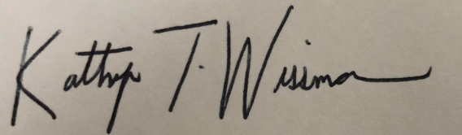Kathryn Wissman

North Dakota State University

Department 2765

P.O. Box 6050

Fargo, ND 58180-6050

Phone: (701) 231-5149

[kathryn.wissman@ndsu.edu](mailto:kathryn.wissman@ndsu.edu)