**Appendix A**

**Lesson plan**

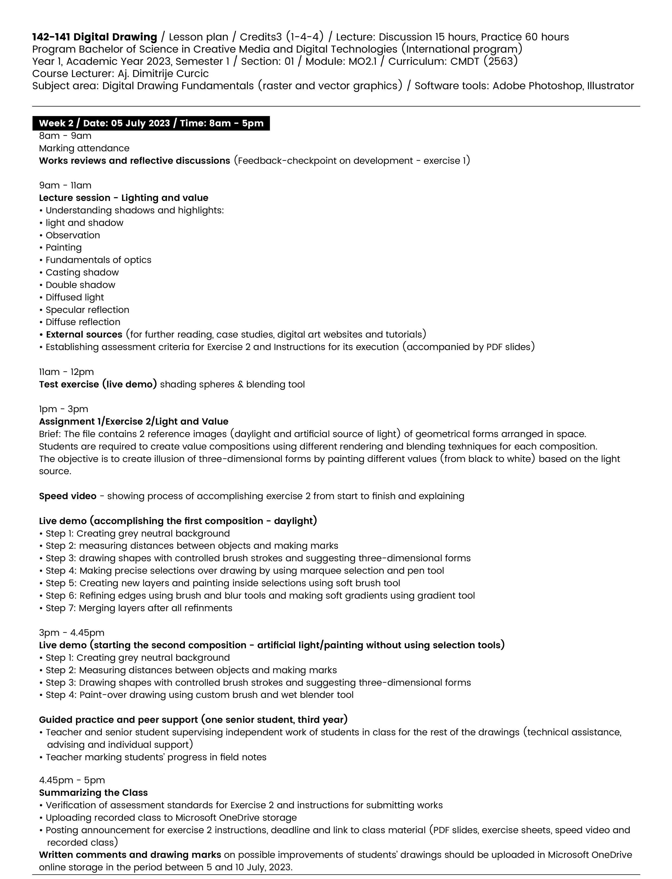

**Appendix B**

**Pre assessment exercise sheet**

*Example drawings are work of student Pornnutcha Pattanathaiyanon.*

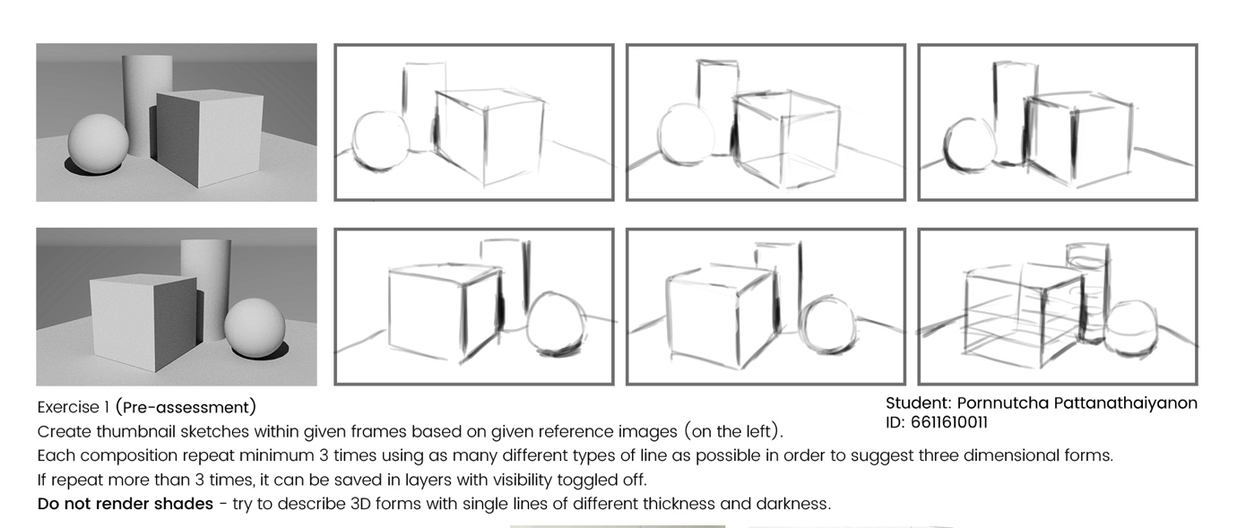

**Appendix C**

**Exercise sheet Light and value (exercise 2, semester 1, 2023)**

*Example drawings are work of student Thitivorada Thongsawat.*

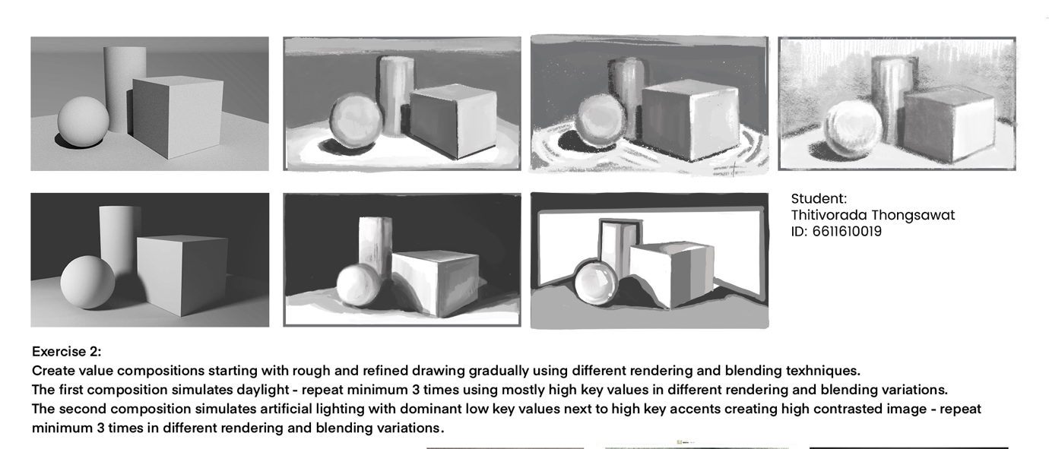

**Appendix D**

**Field notes Light and Value exercise (exercise 2, semester 1, 2023)**

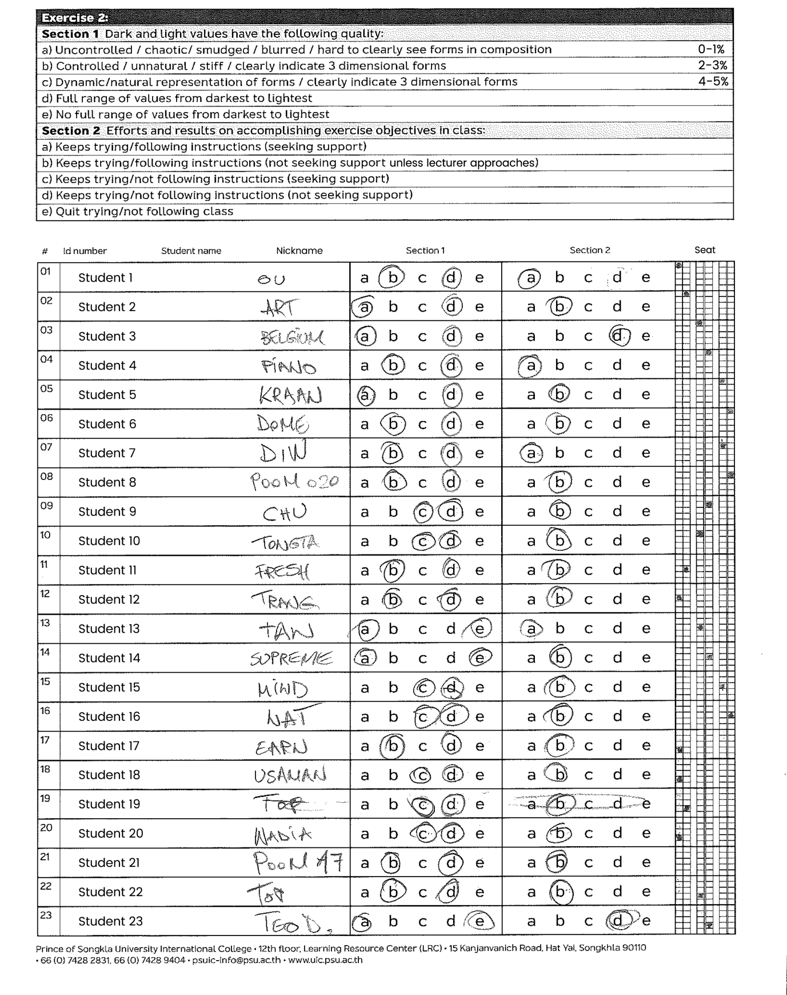

**Appendix E**

**Rubric score criteria Light and Value exercise (exercise 2, semester 1, 2023)**

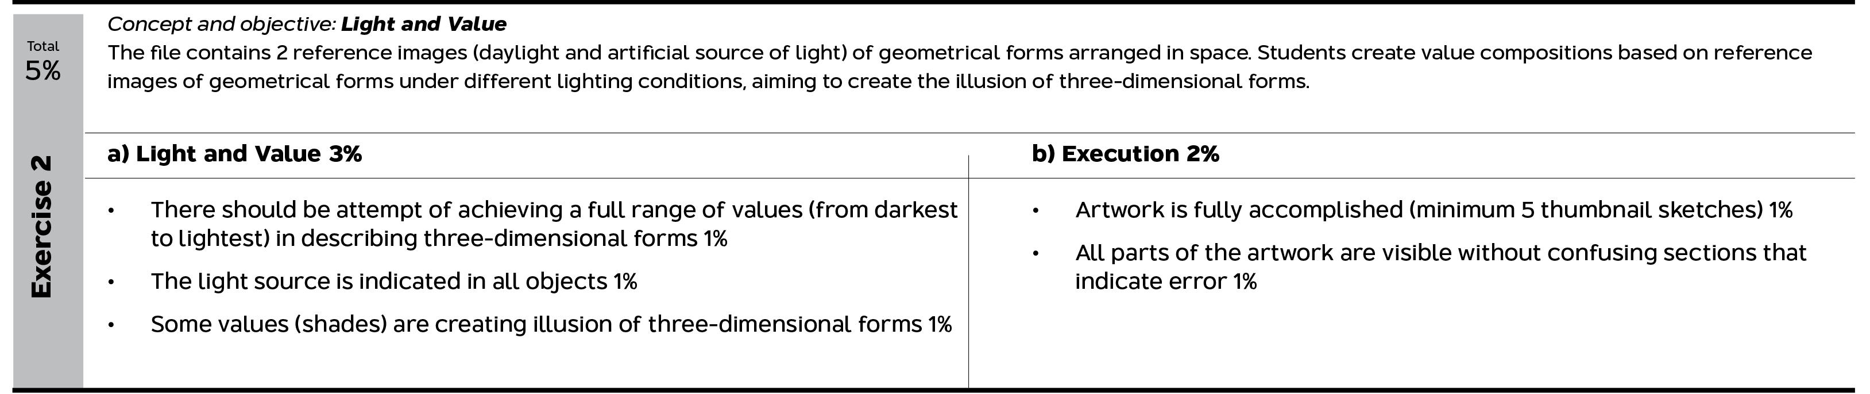

**Appendix F**

**Examples of the students’ works (movie poster illustration) the final project, semester 1, 2023**

*Image 1. Chuhada Hemman, Image 2. Pornnutcha Pattanathaiyanon, Image 3. Natnicha Thongmak , Image 4. Tonboon Jusapalo*

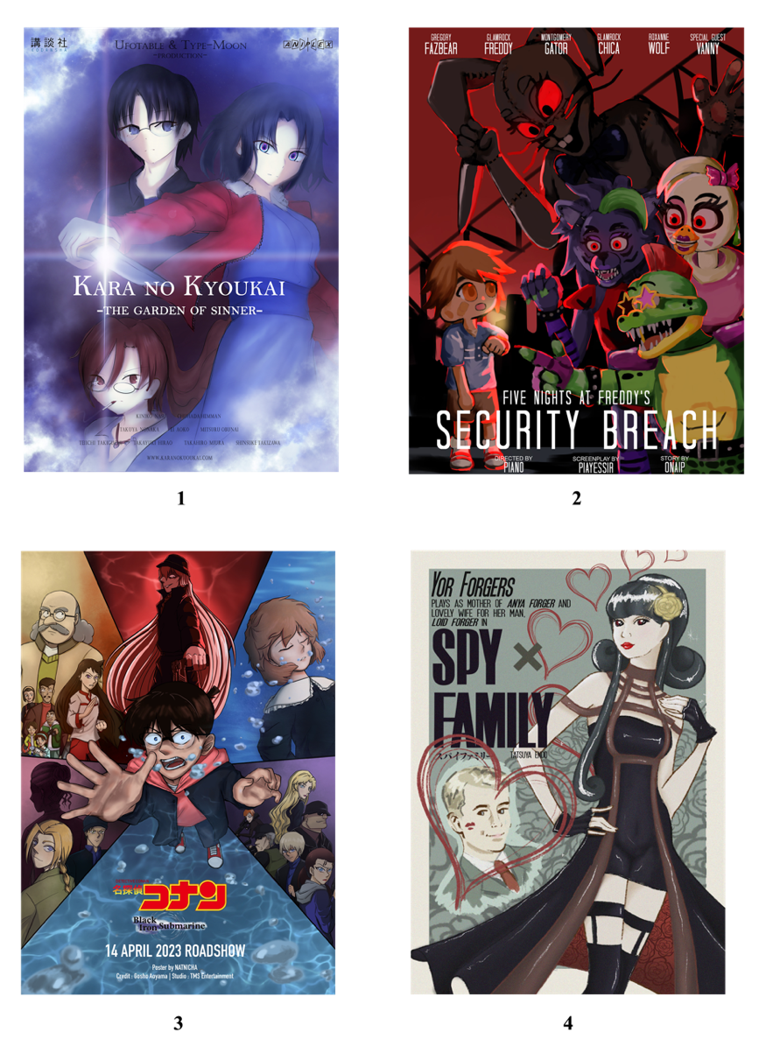

|  |  |
| --- | --- |
| **Author Information** | |
| **Dimitrije Curcic**  Açıklama: Açıklama: orcid logo 16px <https://orcid.org/0009-0006-6531-7254>  Prince of Songkhla University  15 Kanjanavanich Road, Hat Yai, Songkhla 90110  Thailand  Contact e-mail: *dimitrije.c@psu.ac.th* | **First & Last Name of Second Author**  Açıklama: Açıklama: orcid logo 16px https://orcid.org/XXXX-XXXX-XXXX-XXXX  Name of Institution or University  Address of Institution or University  Country  Contact e-mail: *email@email.com* |
| **First & Last Name of Third Author**  Açıklama: Açıklama: orcid logo 16px https://orcid.org/XXXX-XXXX-XXXX-XXXX  Name of Institution or University  Address of Institution or University  Country  Contact e-mail: *email@email.com* | **First & Last Name of Fourth Author**  Açıklama: Açıklama: orcid logo 16px https://orcid.org/XXXX-XXXX-XXXX-XXXX  Name of Institution or University  Address of Institution or University  Country  Contact e-mail: *email@email.com* |